Sheet GB1 (General)

The limestone inquiry

General briefing
You are going to take part in an imaginary Public Inquiry about a limestone quarry.
Rock Quarry Holdings plc (RQH) have a large limestone quarry set in beautiful country in a National Park in the Pennines. RQH have asked the National Park Authority for planning permission to extend the quarry. They want to double the amount of limestone produced. The Authority has refused permission. RQH have appealed against the decision, and now there is to be a Public Inquiry to examine the arguments for and against quarrying.
You will be playing a part in the inquiry, and later, you will have to read a special briefing about your part. But first you should read the rest of this general briefing.

What is limestone?
Limestone is largely the chemical compound calcium carbonate, CaCO₃. It is formed mainly from the remains of organisms that lived in ancient seas, (in this particular area 330 million years ago). Limestone occurs in various parts of England and Wales, including the Pennines, (Figure 1) much of it forming outcrops in National Parks and areas of Outstanding Natural Beauty (Figure 2). Much of this limestone is especially pure, so it is very useful, particularly for the chemical industry.
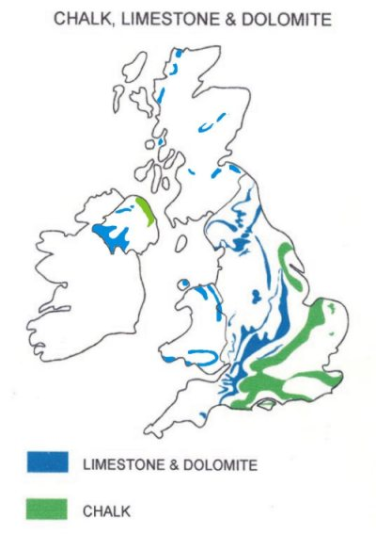Pennines
Figure 1 Deposits of limestone, dolomite and chalk in England and Wales (chalk is also a form of limestone; dolomite is calcium magnesium carbonate) © NSC

Figure 2 National Parks and Areas of Outstanding Natural Beauty in England and Wales © NSC

What happens in a limestone quarry?
The quarry activities, processes and key products are shown in Figure 3. The layout will vary from quarry to quarry and depends on the range of products made.
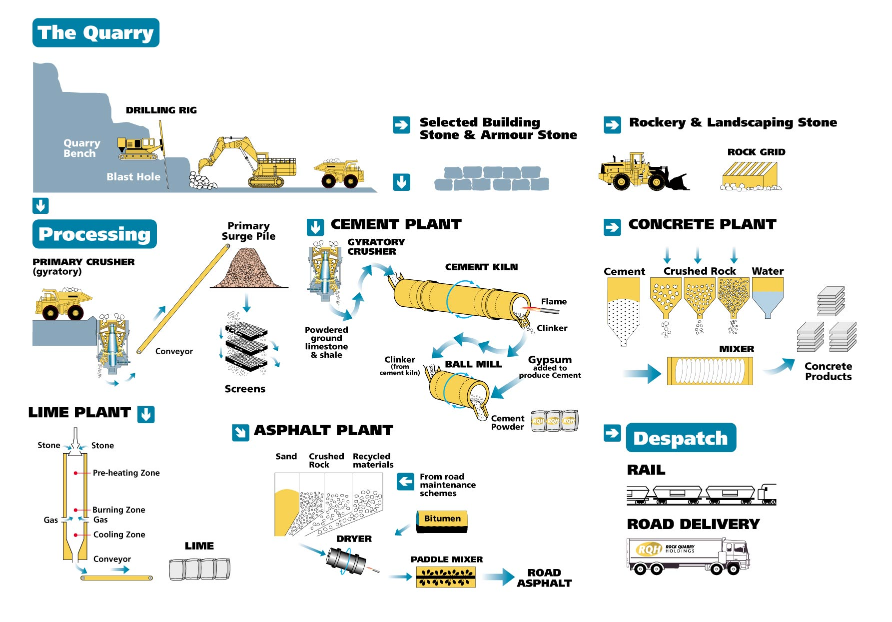
Figure 3 Activities, processes and key products of a typical limestone quarry ©NSC
Over a million tonnes of limestone are taken from the RQH quarry every year. Explosives are used to blast the rock from the quarry face. The quarry face is 2 km long and 30 m high.
The rock is loaded onto huge lorries (‘dumpers’) and taken for crushing and washing. Large mechanical sieves (called screens) are used for sorting it into pieces of different sizes. Some of the limestone is processed on the quarry site. It is used to make other things such as cement and lime (also known as quicklime). Part is carried away by rail or road to customers who use limestone itself. Some of the limestone is used for aggregate. Aggregate is the term for gravel-sized pieces of rock and sand or gravel used to make concrete or in road-building.
Some customers make their own lime, or crush the stone to a very fine powder (called filler) to be added to polymers to make plastics, rubber or paint

What is limestone used for?
The many uses of limestone are covered in more detail in Limestone in your everyday life.
Figure 3 shows the main ways limestone is processed on the quarry site.

What you will be doing

At the Public Inquiry there will be an Inspector, helped by assessors who will listen to arguments for and against the quarry extension. These arguments will be put by the following groups:

For:
- representatives of RQH
- representatives of industrial users of limestone
- representatives of trades unions

Against:
- representatives of the National Park Authority
- representatives of local residents
- members of the local conservation group

The Government’s policy on working minerals in National Parks was first produced in 1949 and called the Silkin Test. This has changed over the years and is now set out in a document known as Minerals Planning Guidance (MPG6): Guidelines for the Provision of Aggregates in England.
In this, the Government considers that major developments should not take place in National Parks and Areas of Outstanding Natural Beauty (AONBs) unless there are exceptional circumstances. Because of the serious impact that mineral developments may have on the natural beauty of these areas, the Government considers that all mineral applications must be very carefully examined, and all mineral developments should be shown to be in the public interest before being allowed to proceed.
So consideration of mineral applications in such areas should normally include an assessment of:
- the need for the development, in terms of the national need for minerals, and the effect of permitting the development, or refusing it, on the local economy
- whether alternative supplies can be made available at reasonable cost; and the scope for meeting the need in some other way
- any negative effect of the proposals on the environment and landscape and the extent to which that should be reduced
- in the case of extensions to existing quarries, the degree to which the proposal would improve the local landscape.

