Plate riding: how is the plate you are on moving now?

Introduction
The following questions will help you to revise your work on plate tectonics and the rock cycle. It should also help you see how these two topics are related.
You may find the diagram on the separate sheet useful.

Questions
Answer the following questions.
Q 1. Wherever you are in the UK you are standing on one of the Earth’s plates. This plate is moving.
(a) In which direction, is it moving?
Choose from east west north south
(b) About how fast is it moving?
Choose from 3 mm per year 3 cm per year 3 m per year
Q 2. Why can’t you tell that the plate moving?
Q 3. What evidence have scientists used to show that it must be moving?
Q 4. Suggest how scientists can now use Global Positioning System (GPS) satellites to show that it is moving.
Q 5. Do all of the Earth’s plates move away form one another? How else can they move?
Q 6. Imagine you are ‘riding’ the moving plate facing in the direction that the plate is moving.
(a) What must be happening behind you? Describe any igneous, sedimentary, metamorphic or deformation activity there.
(b) What must be happening in front of you? Describe any igneous, sedimentary, metamorphic or deformation activity there.
In the following questions decide where the most activity will be. Choose from the middle of the plate, plate margins or plate collision zones.
Q 7. Where will there be most igneous activity? Explain your answer.
Q 8. Where will there be most sedimentary activity? Explain your answer.
Q 9. Where will the most metamorphic activity be? Explain your answer.
Q 10. Where will the most deformational activity be? Explain your answer.

What you found out
Most of the Earth’s geological activity is linked in one way or another to plate tectonics.
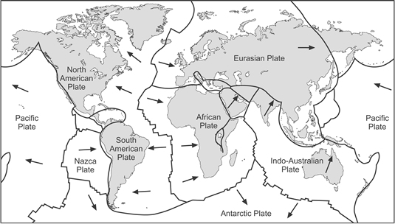
The Earth’s tectonic plates and their directions of movement

