The folding of rocks: lab simulations
This activity will show you how layers of rock can fold when subjected to sideways pressure.

What you will need

Apparatus
- A small plastic box of square cross section (approximately 20 cm x 10 x cm x 10 cm, but the size is not critical). A box such as those in which Ferrero Rocher™ chocolates are sold is ideal.
- Sheet of wood or tough cardboard (approximately the same size as the box’s internal cross-section)

Chemicals
- Soot (or other black powder)
- Sand
- Powdered chalk
- Powdered vermiculite
Note. Your teacher may give you other powders to use. Many powders are suitable provided they are of contrasting colours.

Safety notes
- Wear eye protection

The activity
Place the piece of wood vertically at one end of the box. In the rest of the box, place thin layers (say ½ cm thick) of different powders one on top of the other, see Figure 1. Make sure that there is a good colour contrast between neighbouring layers. Use up to four layers to give a total thickness of about 2 cm. Then slide the wood along the box, keeping it vertical, to compress the layers and produce folding. Stop sliding the wood from time to time, and draw what you can see through one side of the box. Did the layers of powder eventually slide over one another along a ‘fault’?

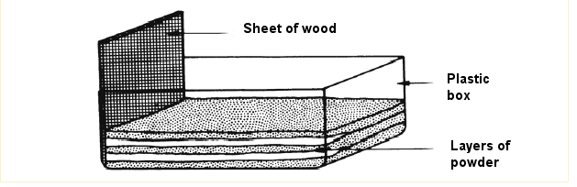
Figure 1 The layers of powder in the plastic box

