Igneous processes: matching the evidence they leave behind

Introduction
Lava from volcanoes solidifies to form rocks that are called igneous rocks.
Igneous rocks can also form in other ways.

What to do
Look at the pictures, 1 to 6.
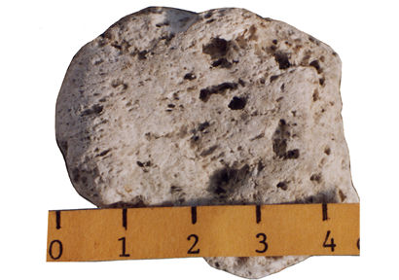 | 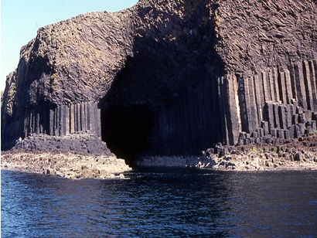
1 | 2
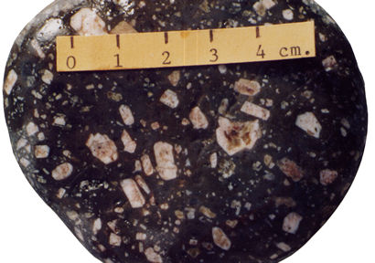 | 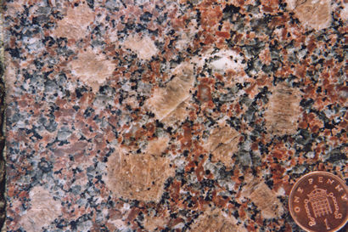
3 | 4
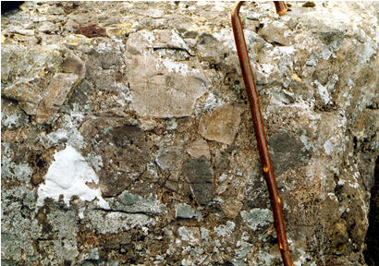 | 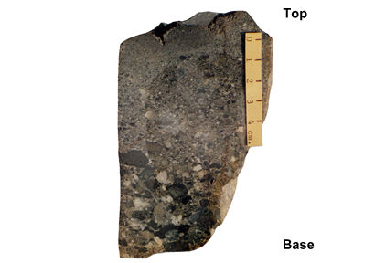
5 | 6

Complete the table to match each picture to the following descriptions.
- This rock crystallised very quickly (in hours), trapping a lot of gas in bubbles in the lava. This results in a texture like a bubbly Aero™ chocolate bar.
- This rock crystallised slowly below ground, where all the crystals had time to grow to a large size (perhaps taking several million years). The rock has a coarse-grained texture.
- The fragments in this rock were blasted out of a volcano up into the air. They landed in the sea and then became cemented together to form a hard rock.
- This lava was erupted quickly, to form a thick sheet. The texture of the rock itself is too fine to see the crystals. As it cooled it contracted to form columns 60 cm or so across.
- This rock began to crystallise from a molten magma, slowly below ground. Then, the magma, with the crystals in it, rose to the surface and erupted from a volcano.
- The fragments in this rock were blasted out of a volcano up into the air. They landed on the sides of the volcano and then became cemented together to form a hard rock.
Picture | Description
1
2
3
4
5
6

Questions
Q 1. Which picture shows a rock that forms in a similar way to the bubbles coming out of the lemonade?
Q 2. Which picture shows a rock that forms in a similar way to the particles settling in the coffee jar demonstration?

