Metamorphic modelling - simulating metamorphic processes

Activity 1
Metamorphic rocks are rocks that have been changed by heat and / or pressure. Sometimes molten rock, called magma, can force itself into a crack in another type of rock. This is called an intrusion. This magma may be extremely hot (temperatures ranging from 700 ºC to 1400 ºC) and this can bring about changes in the surrounding rock. These changes are called metamorphism. This activity shows how this can happen by using egg white to represent the original rock (called the country rock) and a beaker of hot water to represent the intrusion.

What you will need

Apparatus
- A shallow transparent dish (a plastic Petri dish is ideal)
- 100 cm³ beaker
- Bunsen burner, tripod, gauze and heatproof mat

Chemicals
- 1 raw egg white
- Salt (sodium chloride)

Safety notes
- Take care when lifting the beaker of boiling water from the tripod.

What to do
Place the egg white in the Petri dish. Place about 50 cm³ of water in the beaker and add two or three spatulas-full of salt to the water (this is to increase the boiling point) and bring the water to the boil.
When the water is boiling, carefully take the beaker off the tripod and place it in the centre of the egg white on the Petri dish. Use a cloth to hold the beaker. Leave for 10 minutes and observe again. What has happened to the egg white close to the beaker?

Questions
Q 1. Use a dictionary to find out the everyday meaning of the word metamorphism.
Q 2. The change to the egg white has been caused by heating it. Do you think that the change could be reversed by cooling?
Q 3. Do you think that metamorphic rock can easily be changed back to its original form?

Activity 2
This activity simulates the formation of slate by the effect of pressure on mudstone or shale.

What you will need

Apparatus
- A box of used matchsticks, or some short lengths of spaghetti
- Two rulers (approximately 30 cm)

What to do
Pour some used matchsticks, or short pieces of spaghetti onto the bench, so that they lie in all directions. These represent the microscopic, flaky clay minerals in mudstone or shale. Take two rulers and place one on either side of the matchsticks and push the rulers together, trapping the matchsticks and forcing them to line up parallel to the moving rulers.
This simulates the formation of slate, where the tiny, flaky clay minerals in a mudstone or shale are made to line up at right angles to the lateral forces. Such forces could be found near destructive plate margins, in between two approaching continents.
The slate will split along the planes made by the new minerals more easily than along the original bedding. This property is called rock cleavage. You can use the matchsticks / spaghetti to show how such rocks can split along the cleavage by using a ruler to separate the lined up ‘minerals’. Simply by slide a ruler between the lined up pieces of spaghetti.
The slate will split along the planes made by the new minerals more easily than along the original bedding. This property is called rock cleavage, see Figure 1. You can use the matchsticks / spaghetti to show how such rocks can split along the cleavage by using a ruler to separate the aligned ‘minerals’. Simply slide a ruler between the aligned pieces of spaghetti and move them apart.
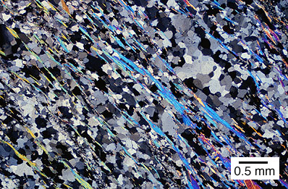
Figure 1 A piece of slate, cut thinly, under the microscope showing the cleavage running from top left to bottom right formed by the aligned minerals
Try to match the way the pieces are lying with a piece of roofing slate. Sometimes, slate shows different coloured bands lying at an angle to the cleavage, see Figure 2. This is the remains of the bedding layers of the original mudstone or shale.
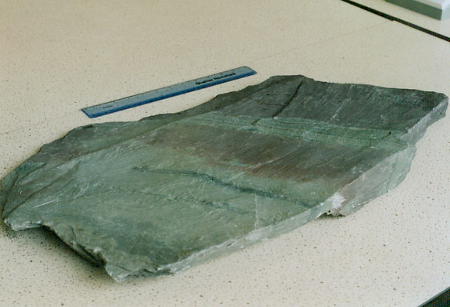
Figure 2 This sample of slate shows coloured layers at about 50º to the cleavage. The coloured layers show the bedding of the original shale.
Under conditions of ever-increasing temperatures and pressures, such slates can be metamorphosed into higher grade metamorphic rocks such as schists and ultimately gneisses.

Activity 3
Many metamorphic rocks, such as slate, are formed deep below ground, under great pressure. They sometimes contain fossils which have been badly squashed. The result of the squashing gives clues about the directions of the pressures which squeezed the rocks.

What you will need

Apparatus
- Modelling clay
- Disposable plastic cup (eg vending machine coffee cup)
- Stirring rod
- A sea shell (eg cockle)

Chemicals
- A little plaster of Paris (calcium sulfate-½-water)

Safety
- Wear eye protection

What to do
- Soften the modelling clay.
- Make a mould by pressing the outside of a shell carefully into the clay. Make a rim around the mould to contain the plaster.
- Carefully remove the shell, to leave the imprint in the clay.
- Squeeze the mould so as to change the shape of the shell imprint, by first choosing whether to squeeze it from top to bottom or from side to side. Alternatively, you could push one side up and the opposite side down. This sort of twisting is called shearing. Whichever you choose, do not distort the shape too much. Note down how you squeezed the mould, it will be important later.
- Mix up some plaster of Paris in a disposable plastic cup. Place less than 1 cm of water in the cup and stir in enough plaster to make a runny cream.
- Pour the plaster into the distorted mould and leave it for a few minutes to set.
- Leave any remaining plaster to set in the cup. Wash the stirring rod.
- When your plaster fossils have set, take your fossil cast out of the modelling clay and then carefully scratch your initials on the base.
- Pass your fossil on to a nearby group. See if they can work out the directions of the pressures which you used to distort the fossil.
- Do the same for theirs. Did you get it right?
How could the same distortion have been produced by forces acting in different directions?

Extension activity
You can simulate the deformation of fossils yourself if you have this Word™ document running on a computer. Just click on Figure 3A to select it and a series of small circles will appear around the image of the fossil. You can then ‘squeeze’ the fossil by clicking on one of the circles in the middle of the left, right top or bottom sides of the diagram and dragging it to resize the image.

Q 4. The fossils (called trilobites) shown in Figure 3 B and C (below) have been distorted compared with fossil A by moderate pressures which have changed the rock in which they were found from a mudstone to a slate. What might have happened to the fossils if the pressures had been much greater?
Q 5. a) (i) In what direction were the forces that squeezed fossil B?
(ii) Estimate by what proportion of its original length it has been squeezed.
b) (i) In what direction were the forces that squeezed fossil C?
(ii) Estimate by what proportion of its original length it has been squeezed.
c) (i) What do your answers suggest about how much the rock in the region in which the fossils were found has been squeezed?
(ii) How might this scale of deformation have been caused?
d) Another similar fossil has been distorted by shearing forces acting in the directions shown by the arrows in Fig 2 D. Sketch the shape that this fossil might have.

A B
C D
Figure 3 The effects of pressure on fossils – A an undistorted trilobite, B and C distorted trilobites, D for you to fill in

