Sequencing of rocks: what was the order of events?

Introduction
Weathering and erosion lead to the breakdown of rocks into smaller and smaller pieces. These are transported to the sea and can, over many years and under suitable conditions, form sedimentary rocks.

Activity 1a - sand layers demonstration of superposition

What you will need

Apparatus
- 100 cm³ measuring cylinder
- glass rod

Chemicals
- about 50g washed yellow sand (sharp sand from a garden centre)
- about 50g washed red sand (builders’ sand)

Safety notes
- Take care when disposing of sand to avoid blocking sinks.
- Take care when pushing the glass rod through the sand.

What to do
Place a large spatula full of yellow sand in the measuring cylinder so that it forms a level layer. Now add a spatula full of red sand to form a second layer. Keep doing this until there are at least six layers with the top layer red. Now push a glass rod through all of the layers, see Figure 1.
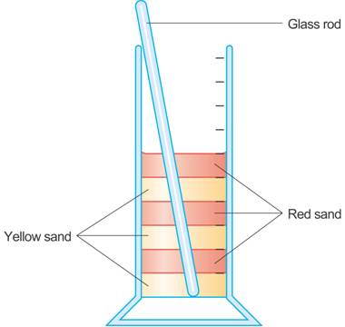
Figure 1 The setup for Activity 1a

Questions
Q 1. Which layer was put in first?
Q 2. Which layer is the ‘oldest’ in the sequence?
Q 3. Which layer is the youngest?
Q 4. What was the last event to happen?
Q 5. What was the overall sequence of events?

Activity 1b – paper layers demonstration of superposition

Apparatus
- sheets of coloured paper

What to do
In this demonstration layers of coloured paper are put one sheet on top of another, yellow at bottom, red on top, any other colours in between, see Figure 2. The pile of sheets of paper is then torn as shown in Figure 3.
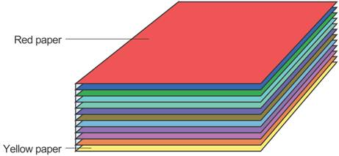

Figure 2 The layers of paper for Activity 1b
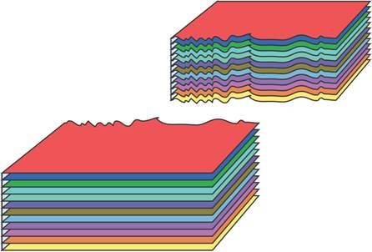
Figure 3 The torn layers of paper in Activity 1b

Questions
Q 6. Which paper sheet was put down first?
Q 7. Which paper sheet is the ‘oldest’ in the sequence?
Q 8. Which paper sheet is the youngest?
Q 9. What was the last event to happen?
Q 10. What was the overall sequence of events?
In these activities you have seen how older rocks are usually lower down in a sequence than younger ones. This is called superposition. Also rocks that cut through others must be younger. If an event such as a fault affects several layers of rock, then it must have occurred after all of these layers were formed.

Activity 2 - demonstration of cross-cutting
Your teacher will show you an experiment (or she may let you do it yourself) that uses a beaker with layers of wax, sand and water to simulate a volcano, see Figure 4.
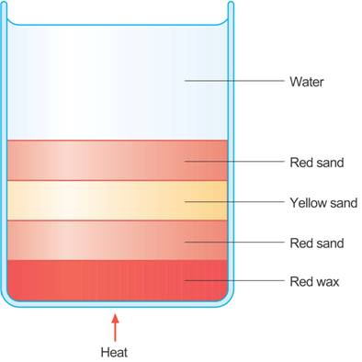
Figure 4 The volcano simulation before heating
The wax represents a layer of rock deep in the Earth. The layers of sand and water represent layers of rock in the Earth’s crust. If the mantle becomes hot, it melts and the resulting molten rock, called magma, rises through the crust. A typical result is shown schematically in Figure 5.
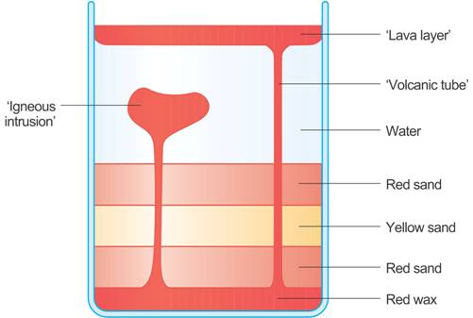
Figure 5 The volcano simulation after heating
Either use the results of your teacher’s experiments or those in Figures 4 and 5 to answer the following questions.

Questions
Q 11. Before heating, what represents the oldest layer of rock?
Q 12. Before heating, what represents the youngest layer of rock?
Q 13. How can you tell from the diagram that the ‘rock’ formed from the candle wax is the youngest?

Extension topics

Repairs in the road
Study the picture of a patched road, Figure 6, to work out the sequence of events.
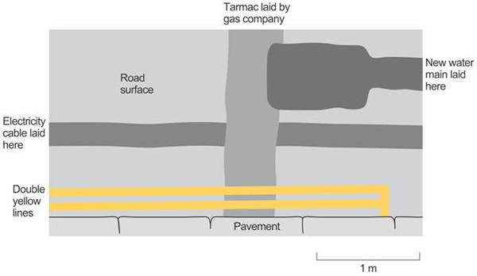
Figure 6 A much-repaired section of road

Question
Q 14. In which order was the work done?

Ancient and modern cross-sections
Look at the two nearly identical diagrams, Figures 7 and 8. The order of events in the archaeological cross section shows that the oldest remains are Roman. After this the medieval remains are more recent and the industrial remains are more recent still. The most recent change of all is the modern bridge support. We know it is the most recent because it has cut through all of the others.
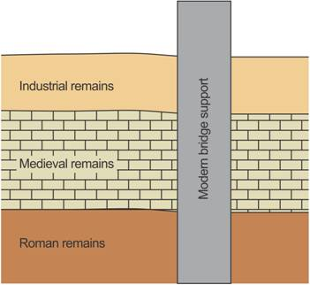
Figure 7 An archaeological cross section

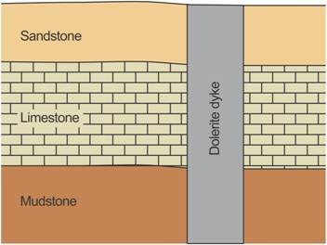
Figure 8 A cross section of a cliff
Now answer the questions about the geological sequence using the same ideas as were used for the archaeology example.

Questions
Q 15. (a) Which rock was the first one formed?
(b) Which principle (superposition or cross-cutting) helped you to work this out?
Q 16. (a)Which rock was the next one formed?
(b) Which principle (superposition or cross-cutting) helped you to work this out?
Q 17. (a) Which rock was the next one formed?
(b) Which principle (superposition or cross-cutting) helped you to work this out?
Q 18. (a) Which rock was the last one formed?
(b) Which principle (superposition or cross-cutting) helped you to work this out?

