Structure of the Earth: the story of the waves
Look at the graph showing the velocities of S-waves and P-waves and answer the questions.
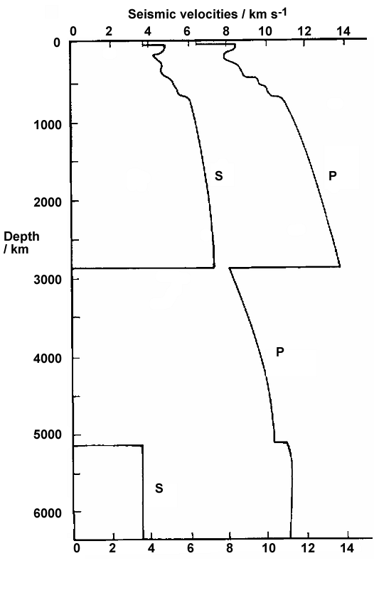

Q 1. (a) Draw dashed lines across the graph to show where S-wave velocity changes suddenly.
(b) Label each of the zones between the lines to show how S-wave velocity changes, for example write ‘wave velocity decreasing’.
Q 2. Why does S-wave velocity drop to zero at a depth of 2900 km?
Q 3. (a) In what way is the P-wave velocity plot different from the S-wave velocity plot between the Earth’s surface and 2900 km depth?
(b) In what way is the P-wave velocity plot similar to the S-wave velocity plot between the Earth’s surface and 2900 km depth?
(c) Draw a dotted line on the graph for the area deeper than 2900 km to show where P-wave velocity changes
(d) Label each of the zones from 2900 km to 6400 km to show how P-wave velocity changes, for example write ‘wave velocity decreasing suddenly’ or ‘wave velocity increasing gradually’.
Q 4. Use the information from the graph and your answers to questions 1–3 above to mark and label on the graph:
(1) the crust (2) the mantle (3) the outer core (4) the inner core
Q 5. Summarise the properties of the different layers labelled 1-4 in the diagram below. The first one has been done for you. (On this diagram the crust is shown thicker than it really is, so that it can be seen.)
(1) ‘P- and S-waves pass through the crust, so it is solid.’
