Magnetic stripes on the ocean floor: a lab simulation

Learning objectives:
- the Earth’s magnetic field has ‘flipped’ (the N pole becoming the S pole, and vice versa) many times over geological time
- as tectonic plates move apart, new rock is formed and locks in the direction of the magnetic field at the time
Timing: 10 minutes
Health and safety: pins are sharp

Introduction:
The discovery of stripes of alternately normal and reversed-magnetised rocks forming the ocean floor was a key piece of evidence convincing most geologists that the theory of plate tectonics was correct. This teacher demonstration shows how this works.
There are two closely related activities which teachers may wish to tackle at the same time. These are:
- Magnetic patterns: ocean floor pattern plotting: analysing magnetic field data –ideas and evidence in science, class activity
- The plate tectonic story: a scientific jigsaw - comprehension exercise

Apparatus:
- magnetised pins stuck onto shaded paper in opposite directions (see Figure 1)
- plotting compasses
- a bar magnet
The paper is folded in half and inserted in a gap between two tables with a bar magnet nearby. As the edges of the paper are pulled apart and a ‘normal’ section of the ‘plate’ appears from the gap, explain that the direction of the magnetism is normal. Then as a ‘reversed’ section of the ‘plate’ appears, reverse the bar magnet and explain that this simulates the reversed magnetic field. Use a plotting compass to show the direction of the magnetic field.
When the paper has been completely pulled out of the gap, remove the bar magnet and pass the plotting compass over the magnetised pins. The magnetism should reverse as it moves from one segment to the next. Here the plotting compass is simulating a ship using a magnetometer to conduct a magnetic survey of the ocean floor.
This indicates the type of data that revealed the magnetism of the ocean floor and provided key evidence for the idea of sea floor spreading.

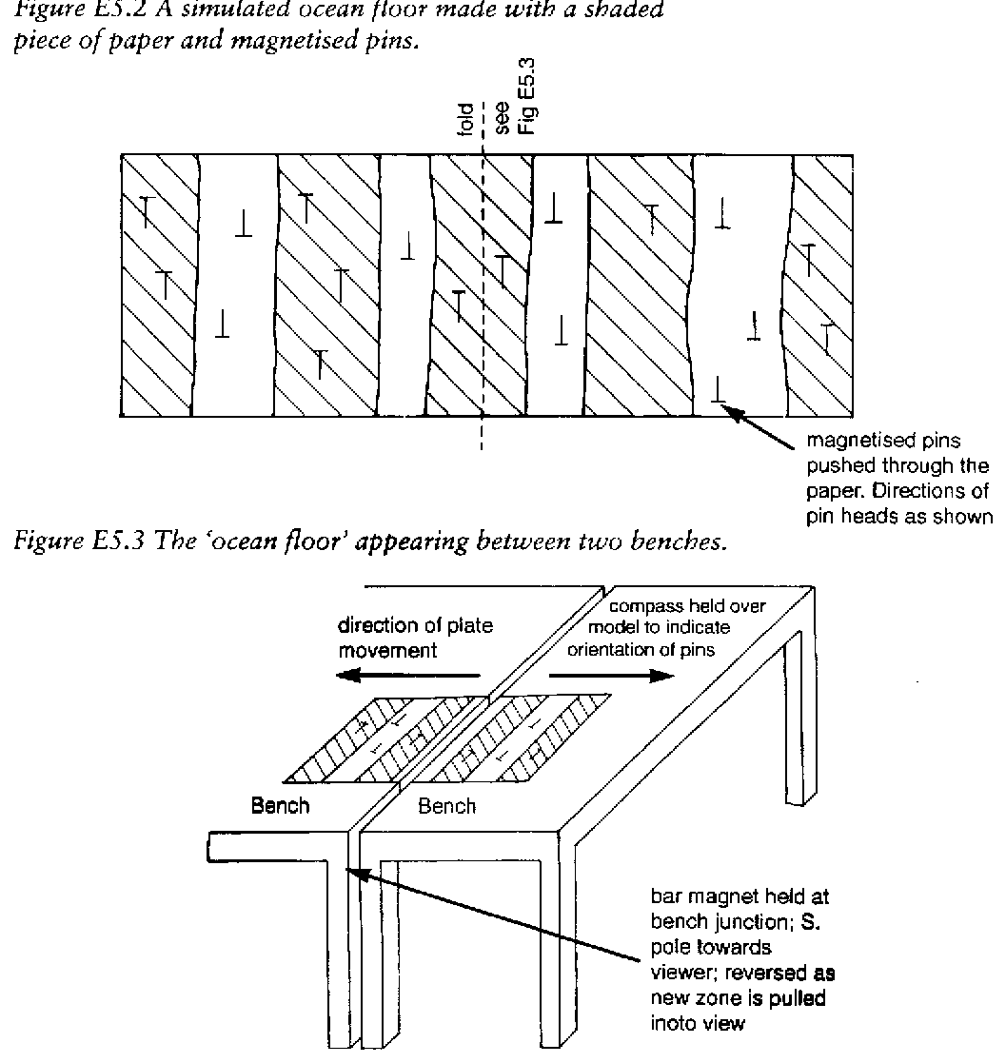

Figure 1 A simulated ocean floor made with a shaded piece of paper and magnetised pins (top) and the ‘ocean floor’ appearing between two benches (bottom)

