Carbon cycle: exchanging carbon dioxide between the atmosphere and ocean (teacher’s notes)

Level
This material is designed for students aged 12 to 14 (years 8 and 9).

Topic
This activity is one of five aimed to teach students about the nature of carbon, the different types of compounds it exists in (eg charcoal, glucose, carbon dioxide), the biochemical reactions it takes part in (photosynthesis and respiration), the range of processes that carbon and carbon compounds are involved in on Earth, and how these link together to form the carbon cycle.
The other activities are
Carbon cycle: where is this crucial carbon?; a teacher-led discussion interspersed with demonstrations in which the teacher burns a range of materials over a Bunsen flame, forming charcoal, to illustrate that they contain carbon.
Carbon cycle in the lab: carbon products and the processes that link them; which involves working in small groups to place examples of the carbon cycle products in the correct places on a diagram of the cycle.
Cycling carbon: seeing how plants use carbon dioxide in the lab; a short pupil practical exploring the uptake of carbon dioxide from the atmosphere by plants for photosynthesis.
Carbon cycle: releasing dinosaur breath in the lab; a short pupil practical exploring the storage of carbon in the fossils that make up limestone and chalk.

Context
An understanding of the carbon cycle is essential to the debate about global warming, an environmental issue that most students will have heard about. Since the Earth’s atmosphere formed, it seems to have always contained carbon dioxide in varying amounts Carbon dioxide is a ‘greenhouse gas’ through which light radiation can pass but which absorbs some of the heat radiation produced by light irradiating the Earth’s surface. This causes the Earth’s surface and atmosphere to be warmer than it would otherwise be and without the ‘greenhouse effect’ the Earth would probably be completely frozen. Humans, as all life on Earth, have always been part of the carbon cycle, but now (since the industrial revolution) the large scale burning of oil, coal and natural gas, along with deforestation, is leading to increasing atmospheric carbon dioxide levels. This in turn is related to an enhanced greenhouse effect and consequent climatic change. An understanding of the factors affecting global warming leads to an understanding of the measures required to reduce their impact. This can link into economic and political debates on the subject. Students should have already covered photosynthesis and respiration in order to do this activity effectively.

Teaching points
There is an exchange of carbon dioxide between the atmosphere and the ocean’s surface. Carbon dioxide dissolves in the ocean and provides the source of carbon dioxide that plants and plankton living in the ocean rely on for photosynthesis. The amount of carbon dioxide the ocean can contain depends on the temperature of the water and on its saltiness (whether it is sea water or fresh water). Warm water can hold more carbon dioxide in solution than cold water. When carbon dioxide dissolves in water, it forms carbonic acid which makes the water acidic. In the lab we can test for the acidity caused by the presence of dissolved carbon dioxide using Universal Indicator, which turns yellow when the solution is acidic. This activity tests whether sea water or fresh water absorbs more carbon dioxide. Sea water can absorb more carbon dioxide than fresh water without having major environmental effects.

Apparatus and materials
Each group of pupils will need:
Eye protection
2 beakers
Universal Indicator solution
Sea water (If real sea water is unavailable, a substitute can be made by dissolving approximately 30 g of sodium chloride in 1 dm³ of water.)
Tap water (fresh water)
Drinking straw
Stopwatch
A copy of the carbon cycle diagram (Figure 1)

Safety
Pupils should wear eye protection, blow gently and not suck up the water. Dispose of straws at the end of the activity.

Activity
The students should work in pairs or small groups. They pour 100 cm³ of sea water into one beaker and 100 cm³ of fresh water into the other. Then they add several drops of Universal Indicator to each so that the colour is clearly visible. Next, using the straw, they blow gently and consistently into the water samples - first the sea water, then the fresh water. For each they time how long it takes the indicator to become yellow and record the results.
When this is done, the students should answer the following questions:
Q 1. What did it mean when the indicator was yellow? = That carbon dioxide had dissolved in the water to produce an acid.
Q 2. Which beaker of water turned yellow the quickest? = The beaker of fresh water.
Q 3. Which absorbs more carbon dioxide without its acidity changing? = Sea water.
Q 4. Highlight this part of the carbon cycle on your diagram. = The arrows indicating exchange of gases at the surface of the ocean should be highlighted.
The following questions concern the whole of the carbon cycle topic.

Overall questions
Q 1. Carbon is in the cycle in solid, liquid and gas forms. Which products show each of these forms (give one example of each)? = For example; atmosphere – CO₂, sea water, dissolved hydrogencarbonate ions (HCO₃⁻), coal – almost solid carbon, or limestone - CaCO₃.
Q 2. Which processes happen quickly (give examples)? Which ones happen very slowly (give examples)? = For example; quick processes – respiration, combustion, slow processes - limestone and coal formation.
Q 3. Which processes are going on outside the window today? = For example; photosynthesis, respiration, CO₂ dissolving in rain (if it is raining), weathering, consumption, excretion and death.
Q 4. Which processes do you take part in? = Respiration, consumption, excretion and death.
Q 5. Which processes did dinosaurs take part in? = Respiration, consumption, excretion and death plus sometimes burial and rock-formation.
Q 6. Coal and natural gas formed from ancient plants. What processes affected these plants that probably won’t affect the plants you see outside the window? = The plants outside are unlikely to become buried and formed into rock – most plant materials rot away in the soil.
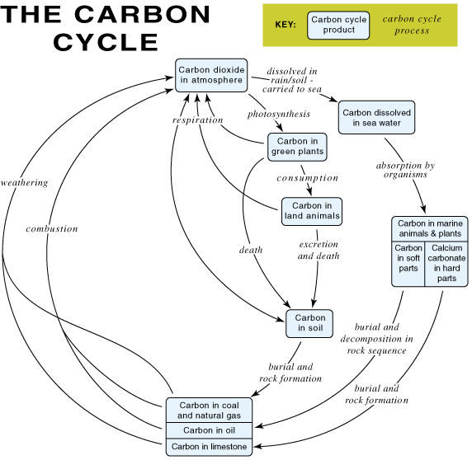
Figure 1 The carbon cycle

