Cycling carbon: seeing how plants use carbon dioxide in the lab (teacher’s notes)

Level
This material is designed for students aged 12 to 14 (years 8 and 9).

Topic
This activity is one of five aimed to teach students about the nature of carbon, the different types of compounds it exists in (eg charcoal, glucose, carbon dioxide), the biochemical reactions it takes part in (photosynthesis and respiration), the range of processes that carbon and carbon compounds are involved in on Earth, and how these link together to form the carbon cycle.
The other activities are
Carbon cycle: where is this crucial carbon?; a teacher-led discussion interspersed with demonstrations in which the teacher burns a range of materials over a Bunsen flame, forming charcoal, to illustrate that they contain carbon.
Carbon cycle in the lab: carbon products and the processes that link them; which involves working in small groups to place examples of the carbon cycle products in the correct places on a diagram of the cycle.
Carbon cycle: releasing dinosaur breath in the lab; a short pupil practical exploring the storage of carbon in the fossils that make up limestone and chalk.
Carbon cycle: exchanging carbon dioxide between the atmosphere and ocean; a short pupil practical comparing how well carbon dioxide dissolves in sea water compared with fresh water.

Context
An understanding of the carbon cycle is essential to the debate about global warming, an environmental issue that most students will have heard about. Since the Earth’s atmosphere formed, it seems to have always contained carbon dioxide in varying amounts Carbon dioxide is a ‘greenhouse gas’ through which light radiation can pass but which absorbs some of the heat radiation produced by light irradiating the Earth’s surface. This causes the Earth’s surface and atmosphere to be warmer than it would otherwise be and without the ‘greenhouse effect’ the Earth would probably be completely frozen. Humans, as all life on Earth, have always been part of the carbon cycle, but now (since the industrial revolution) the large scale burning of oil, coal and natural gas, along with deforestation, is leading to increasing atmospheric carbon dioxide levels. This in turn is related to an enhanced greenhouse effect and consequent climatic change. An understanding of the factors affecting global warming leads to an understanding of the measures required to reduce their impact. This can link into economic and political debates on the subject. Students should have already covered photosynthesis and respiration in order to do this activity effectively.

Teaching points
This activity demonstrates the uptake of carbon dioxide by plants, using Elodea as the example. Elodea is a pond plant that lives below the water surface and thus extracts dissolved carbon dioxide from the water rather than directly from the atmosphere as terrestrial plants do.
Carbon exchange between living things and the atmosphere mostly happens through photosynthesis and respiration. During the growing season leaves take up carbon dioxide. Carbon is stored in the living biomass.
Students should work in pairs for this activity.

Apparatus and materials
Each group of pupils will need:
3 boiling tubes
A drinking straw
Boiled water
Phenol red indicator (which is red and goes yellow in the presence of carbon dioxide)
A sprig of Elodea
Bright light
Carbon cycle diagram (Figure 1)

Safety
Pupils should blow through the straw and not suck. Only one person in the group should use the straw. Dispose of the straws at the end of the activity.

Activity
- Pour about 2- 3 cm depth of water into each boiling tube (the same depth in each).
- Add a few drops of indicator to each.
- Breathe out gently through the straw into two of the tubes until the indicator colour changes to yellow.
- Put the sprig of Elodea into one tube.
- Place all three in bright light and leave them for about 40 minutes.
After this time (during which the students could be doing another related activity), they should observe the boiling tubes’ contents and record their observations by answering the following questions:
Q 1. What happened to the indicator in the tube containing Elodea? = Went back to red.
Q 2. What does this mean? = CO₂ gone/decreased.
Q 3. How do you know it was due to the Elodea? = Because there was no change in other tube.
Q 4. What caused this to happen? = Photosynthesising Elodea took in CO_{2.}
Q 5. Shade in the stage of the carbon cycle on the diagram that this relates to.
Q 6. State two ways in which this carbon can be returned to the atmosphere. = Decay of plant when dead, respiration by plant. Animal eating plant and respiring/ decaying.

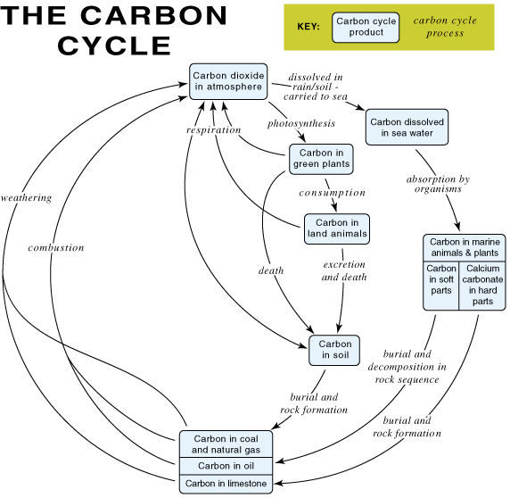
Figure 1 The carbon cycle

