Rock cycle in the lab: Earth products and the processes that link: teachers’ notes

Level
This activity is designed for students aged 11-14.

Topic
The rock cycle.

Description
This whole activity is based on the version of the rock cycle shown in the sheet The rock cycle. This describes the rock cycle in terms of ‘products’ and ‘processes’.
‘Products’ are types of rock, sediment etc, and are presented in boxes.
'Processes' are effects that turn one product into another; for example the process of melting turns one product (metamorphic rock) into another product (magma). ‘Processes’ are presented in italics.
Before the lesson, the teacher lays out in a cycle a set A4 sheets printed with the names of the ‘products’ of the rock cycle shown in the sheet The rock cycle. These must be placed in the correct order around the laboratory.
During the first part of the lesson, students work in small groups, each group having a copy of the sheet The rock cycle on another A4 sheet and a selection of small-scale samples and photographs that represent the ‘products’ of the rock cycle.
The students lay out their samples and photographs next to what they consider to be the correct boxes on their copy of the rock cycle.
After this activity has been completed, the teacher, in discussion with the class, places a set of larger-scale samples and photographs representing the products of the rock cycle on the A4 sheets previously set up around the laboratory.
The teacher then explains the various processes that change one product into the next in the rock cycle and places the ‘process’ A4 sheets between the ‘product’ sheets. He or she also discusses the timescales of the various processes and places A4 sheets relating to these alongside the ‘process’ sheets.
The end result is a large scale rock cycle around the lab consisting of samples or photographs of the products, joined by descriptions of the processes that link them and accompanied by a description of the timescale of each process.

Context
This activity is designed to lead in to a series of activities involving each of the main processes in the rock cycle, including:
Sedimentary rock from sand: syringe simulation
Igneous rocks: completing the 3D picture
Metamorphic modelling: simulating metamorphic processes
Crystal size and cooling rate: fast and slow cooling of lead iodide
Plate riding: how is the plate you are on moving now?
Weathering and erosion: simulating rock attack in the lab

Teaching points
Try to avoid the common misconception that all the processes in the rock cycle take place at the same rate. Different processes may have widely varying rates. The accumulation of sediments on the deep ocean floor is slow – it may take millions of years. A landslip, however, is much quicker - possibly taking place in hours, minutes or even seconds.

Timing
Up to 30 minutes.

Resources
Each group of students will need
- A copy of the sheet The rock cycle.
- A set of specimens and photographs relating to the ‘products’ as detailed in Table 1. The samples, and photographs used by the students should be of small size so that they can be conveniently placed on their A4 rock cycle diagram. Some suitable photographs are found below but there are many other possible sources; postcards are particularly convenient. Click here for details of some suppliers of rock specimens http://www.earthscienceeducation.com/suppliers.
The teacher will need
- A4 sheets printed in large type with the ‘products’, ‘processes’ and ‘timings’ as shown in Table 1.
- Specimens as detailed in Table 1 – these should ideally be larger than the specimens used by the students for easier visibility.
- A4 (or larger) copies of the photographs detailed in Table 1. Some suitable photographs are found below but there are many other possible sources.

Rock cycle products A4 sheets | Specimens, etc | Rock cycle processes A4 sheets | Rock cycle timings A4 sheets
Rocks at the Earth’s surface | Photo of mountain with exposed rocks
 |  | Weathering | Tens to hundreds of years
Rotten rocks and soil | Transparent bag of soil
 |  | Erosion and transport | Seconds to tens of years
Mobile sediments | Transparent bag of sand
 |  | Deposition | Seconds to thousands of years
Sedimentary sequences | Photo of layers of sediments or layered sedimentary rock
 |  | Compaction and cementation | Tens to millions of years
Sedimentary rocks | Specimens of conglomerate, sandstone, mudstone, limestone
 |  | Metamorphism | Millions of years during mountain-building episodes
Metamorphic rocks | Specimens of slate, schist, gneiss, marble and quartzite
 |  | Melting | Tens to millions of years
Magma | Photo of lava from an erupting volcano
 |  | Rising | Days (extrusion) to millions of years (intrusion)
 |  | Crystallisation under the Earth’s surface | Hundreds of thousands to millions of years
Intrusive igneous rocks | Specimens of granite and gabbro
 |  | Extrusion | Seconds to weeks
Extrusive igneous rocks | Specimen of basalt
 |  | Deformation (folding, faulting, metamorphism) | Seconds (faulting at active Earth zones)  Seconds to millions of years (faulting, folding metamorphism during mountain-building episodes)
Table1 Resources required for the activity
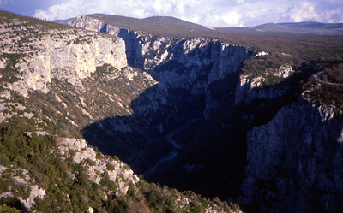
Rocks at the Earth’s surface
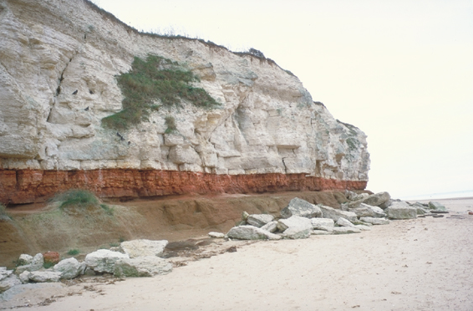
Sedimentary sequences (Photograph by John Simmons © The Geological Society of London, www.geolsoc.org.uk)
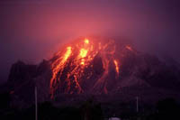
Lava erupting from a volcano (IPR/38-3C British Geological Survey. © NERC. All rights reserved)

The activity
Running order:
- Before the class enter, lay the ‘product’ A4 printed sheets around the room in the same order as in the sheet The rock cycle .
- Give each group of students a copy of the sheet The rock cycle and a set of small-scale specimens and photographs representing ‘products’. Ask them to discuss these and place them on their diagrams in the correct order.
- Discuss with the students the correct answers and confirm these by placing the large-scale ‘product’ samples and photographs in the right places on the rock cycle laid out around the laboratory.
- Link each ‘product’ to the next one in the cycle by laying the ‘processes’ A4 sheets in the gaps between each pair of adjacent products and then discus what the various terms mean.
- After suitable discussion and explanation, add the ‘timings’ A4 sheets to the ‘processes’ A4 sheets to indicate the variable and sometimes very long time scales.

Extension
Use sheets (flash cards) with the rock names on them to lay beside the different rocks so pupils not only hear the rock names but see them written as well.
Discuss which processes are physical, which are chemical, which are biological and which are different combinations of these. It is essential for this part of the activity that students have a grasp of the differences between chemical, physical and biological changes. Some groups of students may need reminding of the key words that they meet in the activity. (Note. Metamorphism does not involve bulk chemical change since the overall chemistry of the rock does not alter. However, chemical change happens to individual minerals as some recrystallise and others are transformed into new minerals – all without melting).

Answers to questions
Q 1.
Rock cycle processes A4 sheets | Chemical, physical or biological?
Weathering | C, P, B
Erosion and transport | P, C
Deposition | P, C
Compaction and cementation | P, C
Metamorphism | P (but see note above)
Melting | P (but chemical changes can result from partial melting, since different minerals melt at different temperatures)
Rising | P
Crystallisation under Earth’s surface | P, C (chemical changes can result from fractional crystallisation, since different minerals crystallise at different temperatures and can be separated from the magma)
Extrusion | P
Deformation (folding, faulting, metamorphism) | P

Q 2. Students may well answer ‘rocks’. A fuller explanation would involve the fact that it is chemicals / minerals that are recycled throughout the cycle. Some minerals are recycled without chemical change through the sedimentary and low grade metamorphic part of the cycle.

Further resources
A Powerpoint™ presentation on the rock cycle is available at www.chemIT.co.uk.

Acknowledgement
This activity is based on the introductory activity of the Earth Science Education Unit ‘The Dynamic Rock Cycle’ workshop – a 90-minute workshop available free to science departments in secondary schools and groups of science teachers everywhere. Click on www.earthscienceeducation.com or contact the ESEU Administrator, Department of Education, Keele University, Keele, ST5 5BG, 01782 584437, mailto:eseu@keele.ac.uk.

