Sequencing of rocks: what was the order of events?: teachers’ notes

Level
This activity is designed for students aged 14-16.

Topic
These activities are aimed at teaching students about the evidence that the order of rocks in a sequence tells us about the relative timing of their formation.

Description
Students use layers of coloured sand and of coloured paper to simulate the sequencing involved in the formation of layers of rock. Combining this activity with the Volcano in the lab. activity about formation of igneous rock, enables the idea of cross-cutting of older rocks by younger rocks to be shown.

Context
It is assumed that students have grasped the concepts of
- weathering and erosion of pre-existing rocks into particles
- the transport of particles by water
- the formation of sedimentary rocks
- how magma cuts through layers of rock when moving from depth towards the surface.
If the activity is not to be done at the same time as the Volcano in the lab. activity, then it would also be useful if students could recall having seen this activity to model the formation of igneous rock.
At the end of the activities students should understand that rocks lower in a sequence are usually older than ones that are higher up. They should also understand that a rock that cuts through another is younger than the one it cuts through.

Teaching points
Students will probably have an intuitive grasp that something lower down must have been put there before something on top of it. These activities reinforce this idea. The aim of Activities 1a and 1b is to introduce students to the idea of rock sequences and hence to understand why layers lower down in a rock sequence must have been formed before ones that are above. In addition the activities show the effect of later events on these layers. The aim of Activity 2 is to introduce students to the idea of igneous intrusions cutting through rock sequences. This enables them to understand that a rock that forms from molten material cutting through other layers of rock, must be younger than the layers it has cut through.

Timing
One lesson of about 50 minutes should be enough to cover the activities, questions and discussion. Each activity will only take 10 minutes. The remaining time will be taken up with follow-up discussion and associated questions.
The link to the next lesson could be activities on folding and faulting and metamorphism.

Activity 1a – sand layers demonstration of superposition
This may be done as a class activity or as a demonstration. If done as a demonstration, it will be easier to have a discussion as the activity proceeds.

Apparatus
- 100 cm³ measuring cylinder
- glass rod

Chemicals
- about 50 g washed yellow sand (sharp sand from a garden centre)
- about 50 g washed red sand (builders’ sand)

Safety notes
- Take care when disposing of sand to avoid blocking sinks.
- Take care when pushing the glass rod through the sand.

Method
Place a large spatula full of yellow sand in the measuring cylinder so that it forms a level layer. Now add a spatula full of red sand to form a second layer. Keep doing this until there are at least six layers with the top layer red. Now push a glass rod through all of the layers, see Figure 1.
Note that it is easier to push the glass rod through the sand layers if the measuring cylinder is half-filled with water before the sand is added. However, the resulting wet sand is more inconvenient to dispose of than dry sand.
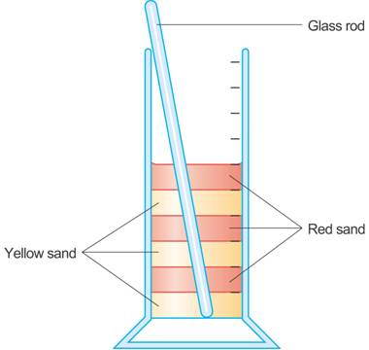
Figure 1 A demonstration of superposition

Activity 1b – paper layers demonstration of superposition

Apparatus
- sheets of coloured paper

Place layers of coloured paper, one sheet on top of another, yellow at the bottom, red on top, any other colours in between, see Figure 2. Now tear across all the sheets of paper, Figure 3.
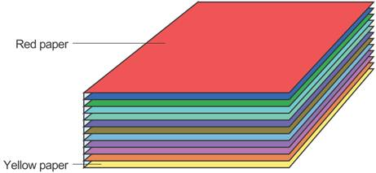
Figure 2 Layers of coloured paper
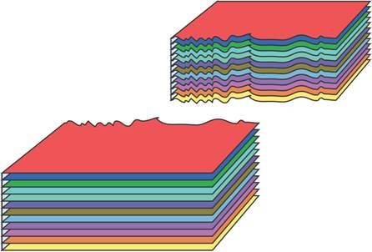
Figure 3 Layers of coloured paper after tearing

Points to bring out
Students need to appreciate that the layers of sand and paper are meant to model layers of rock. Although we have put them on top of each other quickly, the geological processes would occur over a much longer time scale.
The layer that is lowest in the sequence is the oldest. Layers above get progressively younger. This is called superposition.
Anything that cuts through another layer must be younger than the one it cuts through. This is called a cross-cutting relationship. This is shown by the pushing of the glass rod through the layers of sand.
The tearing of the paper represents a fault process that has affected all the layers, it must have happened after all of the layers were deposited.

Answers to questions
Q 1. The lowest layer of yellow sand
Q 2. The lowest layer of yellow sand
Q 3. The top layer of red sand
Q 4. The glass rod going through all of the sand layers
Q 5. The lowest layer of yellow sand was first, then layer of red sand above it, and so on until all of the layers were cut through by the glass rod
Q 6. The lowest yellow sheet of paper
Q 7. The lowest yellow sheet of paper
Q 8. The top red sheet of paper
Q 9. All the sheets were torn (‘a fault’)
Q 10. The lowest yellow sheet was first and so on (depending on colours used) until final red sheet at top, then all of the sheets were torn.

Activity 2 – demonstration of cross-cutting
Carry out the Volcano in the lab. activity but use several layers of different coloured sand. The layers should be quite thin, giving a total depth of sand of about 1 cm. Alternatively, use Figures 4 and 5, which show typical results, as a basis of discussion and questions. These figures are schematic and the thickness of the sand layers has been increased for clarity.
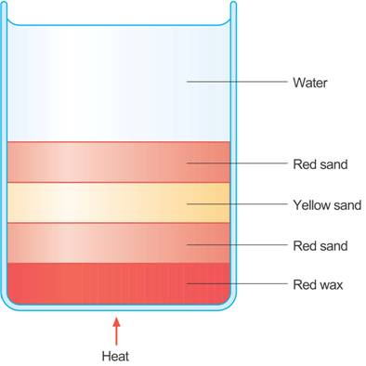
Figure 4 The volcano in the lab. before heating
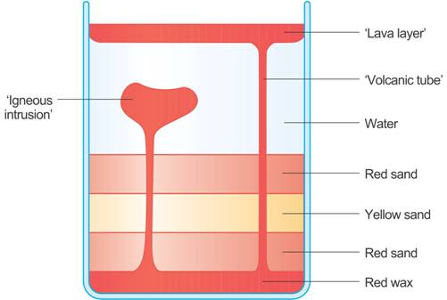
Figure 5 The volcano in the lab. – a typical result after heating

Points to bring out
Emphasise that the red wax represents solid ‘rock’ (probably solid igneous rock). Above this are three layers of sand that represent layers of sedimentary and metamorphic rocks. Particularly emphasise that the water above this also represents a sedimentary rock layer.
The wax is heated at one spot to represent a ‘hot spot’ in the mantle. This melts the wax (‘rock’), which rises through the covering layers of ‘rock’. As the wax sets it forms ‘igneous rock’. The igneous rock on the surface is clearly younger than the layers below. However, the most important point is that the igneous rock that forms in the tubes cutting through the ‘sedimentary rock layers’ is also younger than the layers it is cutting through.

Answers to questions
Q 11. Before heating, the oldest ‘rock’ is the layer of wax.
Q 12. Before heating, the youngest ‘rock’ is the layer of water.
Q 13. The other layers must have been there first in order for the wax to be able to cut through them.

Extension topics

The extension work consists of a series of questions relating to superposition and cross-cutting in different situations.

Answers to questions (extension topics)
Q 14. Later holes cut across earlier holes so that later patches cut across earlier patches. This illustrates cross-cutting relationships. Any lines painted on top of the patches must have come last. This illustrates superposition. So
- the electricity cable is the oldest
- the gas is the next oldest
- the water main is the youngest / most recently laid
- double yellow lines are younger than both electricity and gas but it is not possible to say whether they are younger than the water main
Q 15. (a) Mudstone
(b) Superposition
Q 16. (a) Limestone
(b) Superposition
Q 17. (a) Sandstone
(b) Superposition
Q 18. (a) Dolerite
(b) Cross-cutting

