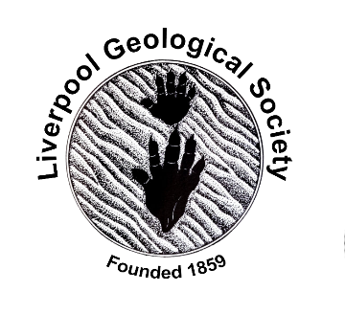 | 1st February 2021  LGS Newsletter 162.7

Liverpool Geological Society message
Tuesday 9th February and Tuesday 16th February 2021
Online Lyell events
If you were unable to attend the LGS virtual lecture on Tuesday 26th January presented by Dr. David McClay, University of Edinburgh: ‘Charles Lyell Papers’, please note that there in an online event on 9th February (and repeated on 16th February). Much of the content from David McClay’s talk will be part of these new events, but with others also speaking. (It may not therefore be of interest to those members who attended David’s event, although you are welcome to join, but if there were any members who wanted to but could not attend David’s talk on 26th January, then these upcoming events may be of interest.
Details and booking are via Eventbrite:
https://www.eventbrite.co.uk/e/introducing-charles-lyells-world-online-tickets-136611076407
Reminder: David McClay, Philanthropy Manager, Library and University Collections at the University of Edinburgh and colleagues, will present an illustrated update on their Charles Lyell collections and access plans. Having built an unrivalled archive, including his fascinating notebooks, the focus now is on transforming the collection into a free online resource through the Creating Charles Lyell’s World Online project.

Herdman Geological Society event
Saturday 20th & Sunday 21st February
Event: Herdman Symposium: “Dynamic Earth”
This is the first Virtual Symposium organised by the Herdman Society. There are speakers from the UK, Italy, and USA this year so there will be something for everyone.

Members of Liverpool Geological Society are invited to attend. As the symposium will be free this year, there will be an opportunity to donate to GfGD. The way to sign-up for the Symposium is through the following Google Forms link:
https://tinyurl.com/y38vxkt9

If you fill out the form you will be added to an email list and Megan and Jade (Symposium Secretaries) will send you further details such as Zoom and GfGD donation links.

Please note:
- The Society is limited to 280 people per day (Zoom limitations), so you are recommended to sign up as soon as possible.
- In case people are unable to join the event, the talks will be recorded and made publicly available.
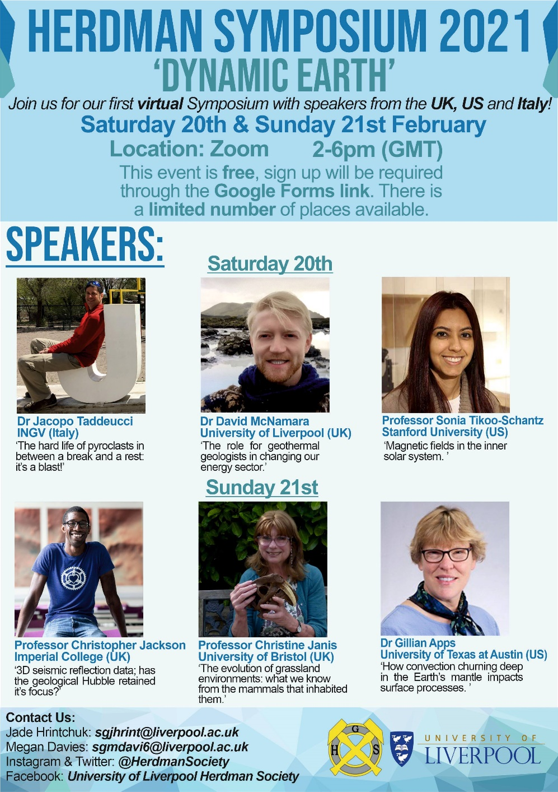

Yorkshire Geological Society (YGS) & Hull Geological Society (HGS) event
Wednesday 3rd February 2021
Lecture by Patrick Boylan “New Light on the Neanderthals”

The Council of YGS has approved the hosting of this Hull Geological Society event. Booking details below. Please note that the scheduled start time for the talk is 7.30pm

You are invited to a Zoom webinar on February 3rd 2021 at 07:15 PM London. Register in advance for this webinar: https://us02web.zoom.us/webinar/register/WN_yGZ-HSWwTByw8XWJnXZuFg

After registering, you will receive a confirmation email containing information about joining the webinar. You will be admitted to the meeting between 7.15pm and 7.30pm by the host(s).
Should you find the event fully booked, please be aware that you can follow the talk on YouTube by joining via the YGS website and selecting the YouTube channel or clicking on this link:
https://www.youtube.com/channel/UCzBPkcmYZbbLnaez7_tuohg
Please note that the talk will not be available before 7.30pm.

