Fieldwork sites to explore in Google Earth Street View
Locality | Google Earth Street View link
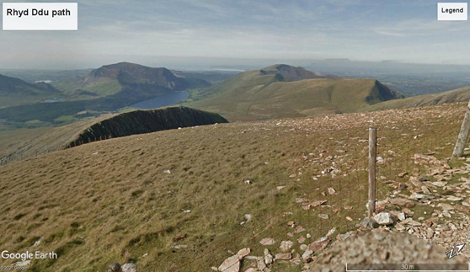 | https://www.google.com/maps/@53.0612114,-4.0863057,2a,75y,294.13h,78.64t/data=!3m6!1e1!3m4!1s0CnaqLG-jyr4f2dkfnpIEw!2e0!7i13312!8i6656
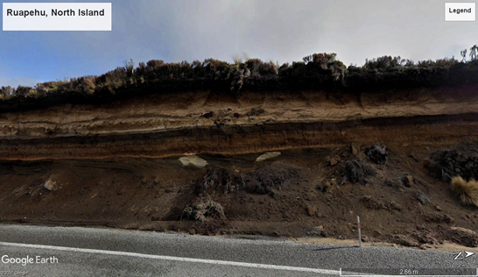 | https://www.google.com/maps/@-39.2878841,175.7408212,3a,75y,296.61h,91.06t/data=!3m6!1e1!3m4!1sDfam39xpr_r7rHqucZVMEg!2e0!7i16384!8i8192
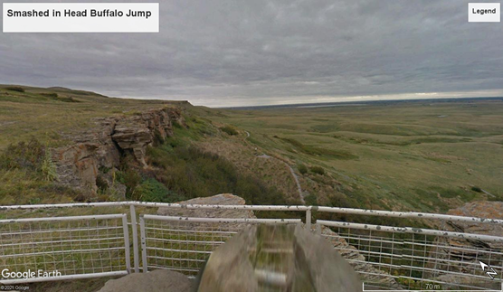 | https://www.google.com/maps/@49.709675,-113.6500775,2a,75y,11.99h,108.53t/data=!3m9!1e1!3m7!1sM8kQBdlkW9SkMf5BJCuOwQ!2e0!7i13312!8i6656!9m2!1b1!2i51
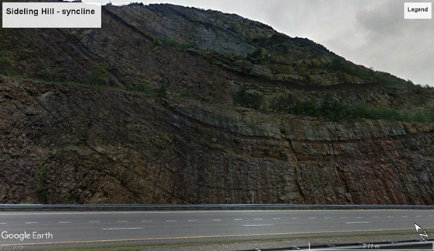 | https://www.google.com/maps/@39.7193225,-78.2832842,3a,75y,17.18h,97.37t/data=!3m7!1e1!3m5!1sfnlsoJhkvu-n7UDpWBQq6Q!2e0!6s%2F%2Fgeo0.ggpht.com%2Fcbk%3Fpanoid%3DfnlsoJhkvu-n7UDpWBQq6Q%26output%3Dthumbnail%26cb_client%3Dmaps_sv.tactile.gps%26thumb%3D2%26w%3D203%26h%3D100%26yaw%3D28.64221%26pitch%3D0%26thumbfov%3D100!7i13312!8i6656
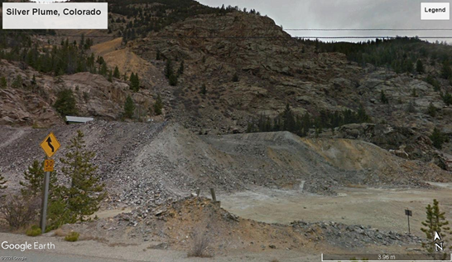 | https://www.google.com/maps/@39.6959401,-105.7354967,3a,75y,1.83h,113.76t/data=!3m10!1e1!3m8!1sXF8cqMZqWu8ME95hp0vIxg!2e0!6s%2F%2Fgeo1.ggpht.com%2Fcbk%3Fpanoid%3DXF8cqMZqWu8ME95hp0vIxg%26output%3Dthumbnail%26cb_client%3Dmaps_sv.tactile.gps%26thumb%3D2%26w%3D203%26h%3D100%26yaw%3D349.1197%26pitch%3D0%26thumbfov%3D100!7i13312!8i6656!9m2!1b1!2i51
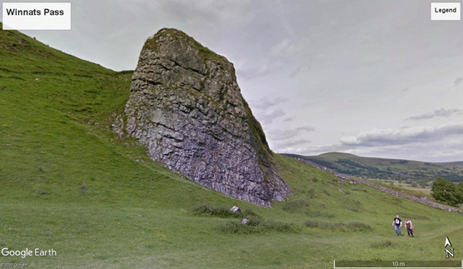 | https://www.google.com/maps/@53.3413403,-1.7930117,3a,75y,225.16h,108.39t/data=!3m6!1e1!3m4!1sjG8Y1WdFrn7yOLZ_YTM9-Q!2e0!7i13312!8i6656
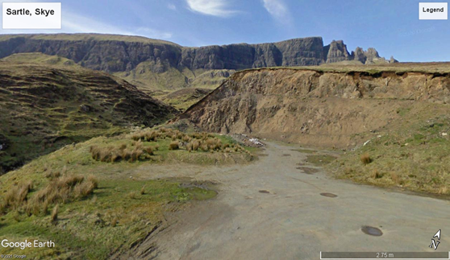 | https://www.google.com/maps/@57.6301648,-6.2742264,3a,75y,325.82h,90.87t/data=!3m6!1e1!3m4!1sxoT_m--d_izkBNdQwZOalw!2e0!7i13312!8i6656
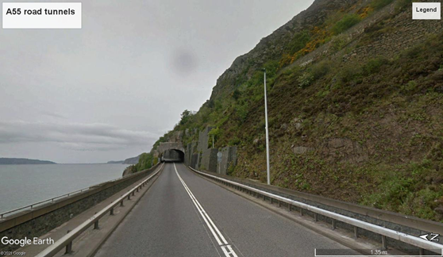 | https://www.google.com/maps/@53.2662553,-3.9533935,3a,75y,100.03h,90t/data=!3m7!1e1!3m5!1sKQqf6cHCqLiuT4KH9z95pQ!2e0!6s%2F%2Fgeo1.ggpht.com%2Fcbk%3Fpanoid%3DKQqf6cHCqLiuT4KH9z95pQ%26output%3Dthumbnail%26cb_client%3Dmaps_sv.tactile.gps%26thumb%3D2%26w%3D203%26h%3D100%26yaw%3D106.47752%26pitch%3D0%26thumbfov%3D100!7i13312!8i6656
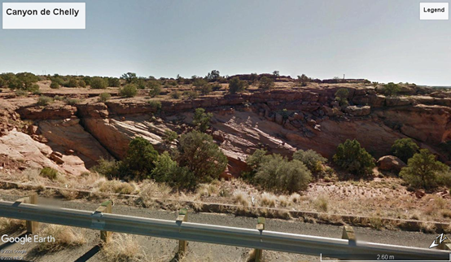 | https://www.google.com/maps/@36.1764551,-109.5162404,3a,75y,161.83h,88.89t/data=!3m6!1e1!3m4!1scO2YyMl7XSGUcMruAlBBMA!2e0!7i13312!8i6656
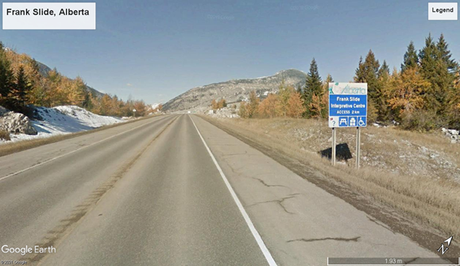 | https://www.google.com/maps/@49.5894645,-114.3839698,3a,75y,322.44h,79.68t/data=!3m6!1e1!3m4!1sCnvgZu4Ijz-W221o0K_FYA!2e0!7i13312!8i6656
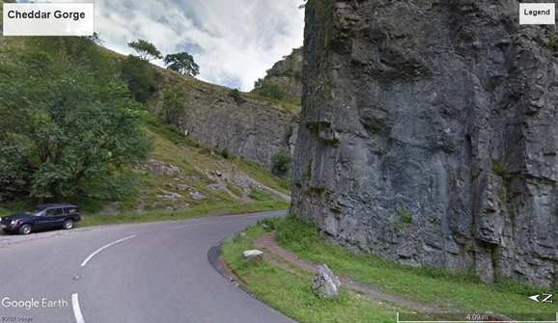 | https://www.google.com/maps/@51.28548,-2.75896,3a,75y,36.19h,93.58t/data=!3m7!1e1!3m5!1sk7kNiDENWtYAyG0Q4euQcg!2e0!6s%2F%2Fgeo3.ggpht.com%2Fcbk%3Fpanoid%3Dk7kNiDENWtYAyG0Q4euQcg%26output%3Dthumbnail%26cb_client%3Dmaps_sv.tactile.gps%26thumb%3D2%26w%3D203%26h%3D100%26yaw%3D69.54466%26pitch%3D0%26thumbfov%3D100!7i13312!8i6656
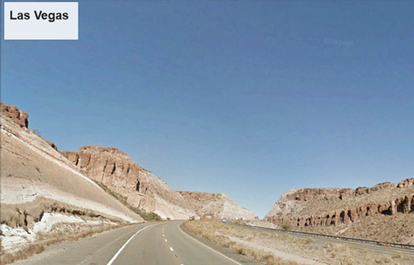 | https://www.google.com/maps/@35.1734941,-114.0755236,3a,75y,318.82h,98.25t/data=!3m7!1e1!3m5!1ss5UZzO8b8QvBGnCMPoYfTQ!2e0!6s%2F%2Fgeo2.ggpht.com%2Fcbk%3Fpanoid%3Ds5UZzO8b8QvBGnCMPoYfTQ%26output%3Dthumbnail%26cb_client%3Dmaps_sv.tactile.gps%26thumb%3D2%26w%3D203%26h%3D100%26yaw%3D71.19159%26pitch%3D0%26thumbfov%3D100!7i13312!8i6656
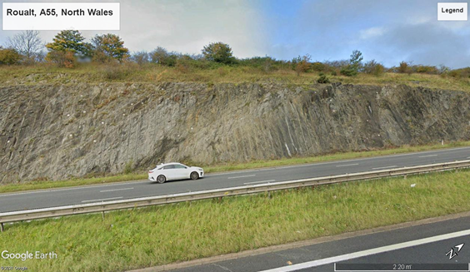 | https://www.google.com/maps/@53.2633434,-3.3852091,3a,75y,315.96h,79.15t/data=!3m6!1e1!3m4!1sR02rNBAMRVlBQvfCec-yyQ!2e0!7i16384!8i8192
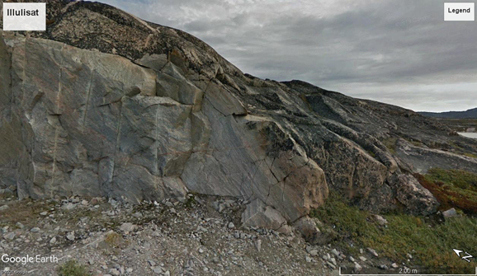 | https://www.google.com/maps/@69.2239364,-51.091131,3a,75y,33.03h,86.09t/data=!3m6!1e1!3m4!1saacNvXy-ixXrr613keUG8A!2e0!7i13312!8i6656
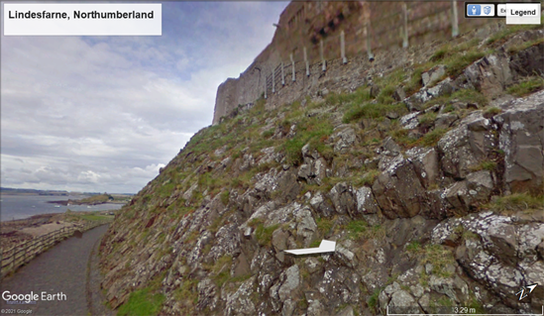 | https://www.google.com/maps/@55.6688548,-1.7844205,3a,90y,334.97h,87.36t/data=!3m6!1e1!3m4!1s6CBqxOJkiCuis2lwytjZfg!2e0!7i13312!8i6656
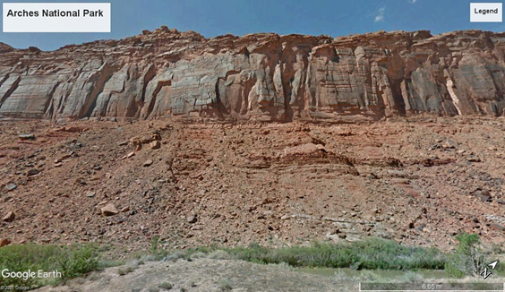 | https://www.google.com/maps/@38.6795274,-109.4833784,3a,75y,24.27h,104.78t/data=!3m7!1e1!3m5!1sfv6TF6_XtGW3rk4i3V2Vqw!2e0!6s%2F%2Fgeo2.ggpht.com%2Fcbk%3Fpanoid%3Dfv6TF6_XtGW3rk4i3V2Vqw%26output%3Dthumbnail%26cb_client%3Dmaps_sv.tactile.gps%26thumb%3D2%26w%3D203%26h%3D100%26yaw%3D148.7216%26pitch%3D0%26thumbfov%3D100!7i13312!8i6656
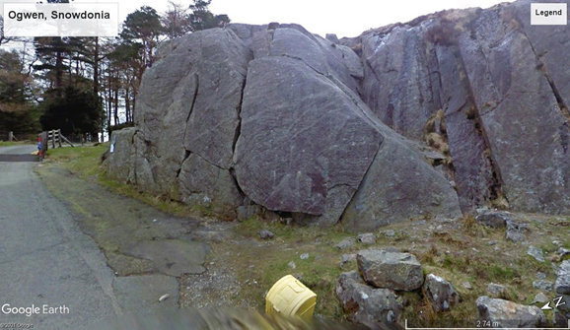 | https://www.google.com/maps/@53.1235018,-4.0226744,3a,75y,53.99h,89.64t/data=!3m6!1e1!3m4!1su49oKeuc5zzqkYvxRyLOAw!2e0!7i13312!8i6656
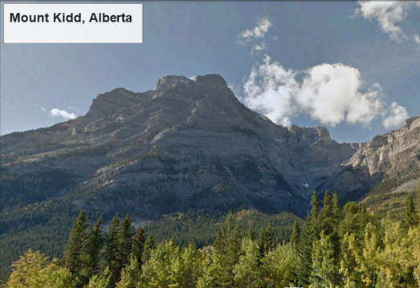 | https://www.google.com/maps/@50.8645886,-115.1764587,3a,75y,327.6h,99.7t/data=!3m9!1e1!3m7!1svwVWEog512FXT20ygEUuVQ!2e0!7i13312!8i6656!9m2!1b1!2i50

