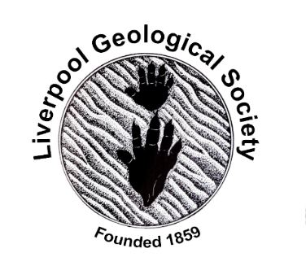 | LGS News Flash  13th March 2021
Herdman Geological Society

Tuesday 16th March at 5:30pm
Virtual lecture by Professor Ric Williams: 'Climate Futures'.

The talk will firstly address our research on how surface warming connects to carbon emissions in climate projections, and secondly advertise a new University research theme addressing the science, societal response and solutions.

Speaker biography:
Prof Ric Williams is conducting research on the climate response to carbon emissions. He is a Chair in Ocean Sciences at University of Liverpool.
He did a Physics degree at Bristol University, a Masters in Atmospheric Sciences at Imperial College, a PhD in Ocean Sciences at UEA. He worked as a researcher at Imperial College and then at MIT, USA as NOAA Research fellow, before moving to University of Liverpool. He is now a co-lead of the University research theme “Climate Futures".

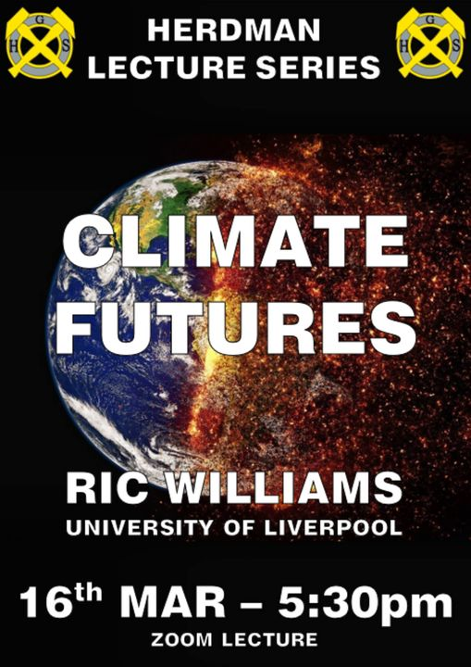

Zoom details:
https://l.facebook.com/l.php?u=https%3A%2F%2Fliverpool-ac-uk.zoom.us%2Fj%2F94369868487%3Fpwd%3DNlgvTWthRVVOZmRzYSs2dFdNMXNGZz09%26fbclid%3DIwAR0j3LsxJMiXfJ24iCny-Jin8II_49SqG5fnGvHpvOVKayt5ay-ml7Y99dM&h=AT3QkbfS5UYPnHSLZq5zwxW6bSHx-0xOOvGtU625iDEPvCWP4BA2TwGD4ehvVO2GRxhImwF7WhhMfu1Nq6N5WOCS6TXkHZcWxH9-59QET1sfnuD7-d-CYShBkXJm5qRJnw&__tn__=-UK-R&c[0]=AT2CDkAo7dGzVE2OVA5QojbKvQ-m4dvszllkGy9sDY3z0bvb5NBGiXvQBKizB72MC5X_QgcX8gWPEo85rH9bksn_-Pf5SndPJhepf0Z5R7lebm45Da2iK51oqfAe5ImP6YiuPKREa9xM1oOUwGue_yV3G1HkkECkXAxKP3tvB2AdZV8B-wl9D5Q4q8dKw65BZq9nK288Zgwcpbfc0w

Leeds Geological Association (LGA)

Thursday 18th March at 7.15 p.m.
Virtual lecture by Alison Tymon of West Yorkshire Geological Trust: ‘The Rocks and Landscapes of Duns, Scottish Borders’

Abstract
Duns was the county town of the historic county of Berwickshire, so has a glorious history and some pleasant buildings in the centre of the town. The surrounding countryside has sedimentary and igneous rocks, ranging from Silurian greywackes and Old Red Sandstones to Carboniferous igneous and sedimentary rocks. Nearby is a potential golden spike locality between the Devonian and the Carboniferous periods, as well as many towers and castles positioned on top of volcanic plugs.
For a map to locate the town of Duns and more information about Berwickshire’s geology, try: http://berwickshirerocks.org.uk/placestovisit.html
Joining instructions:
Non-members are welcome to join the talk which will be delivered via Microsoft Teams. If you wish to do this, please Email the LGA Secretary lga.sec@btinternet.com no later than 24 hours before the talk is due to start. The joining link will be sent out on the day of the talk.

Geological Society of London
Wednesday 14th April 2021 at 6.00 p.m.
Virtual Public Lecture by Frances Wall (University of Exeter): ‘Responsible manufacturing – getting it right from the start’

Speaker biography:
Frances Wall is Professor of Applied Mineralogy at Camborne School of Mines (CSM), University of Exeter, UK. She has a BSc in Geochemistry and PhD from the University of London, and worked at the Natural History Museum, London, before joining CSM in 2007.

Her research interests include the geology, processing and responsible sourcing of minerals, especially technology and critical raw materials. Frances has recently led two international projects, SoS RARE and HiTech AlkCarb, and is working on aspects of economic development using georesources in Cornwall. She was named one of the ‘100 global inspirational women in mining 2016’ and received the William Smith Medal from the Geological Society in 2019.

Registration: You can book free tickets for your lecture of choice now via Eventbrite. Details via
https://www.geolsoc.org.uk/04-postponed-gsl-public-lecture-apr-2020

