24th August 2021

LGS Newsletter 162.11

Please note that this is the final LGS Newsletter for the 2020-21 session.
Details about meetings for the 163rd session will be published in LGS Newsletter 163.1, which will be sent out on the September 25th and published on the LGS website: https://liverpoolgeologicalsociety.org/

Liverpool Geological Society events
Field excursion
Saturday 4 September. Wirral coastal defences Kings Parade to Leasowe Bay
Field Leader: Hazel Clark
Meet at 11 am at the Coast Guard Station, near junction of Harrison Drive and Kings Parade. [53 26 03.01 N. 3 04 31.10 W]. Plenty of free parking on Kings Parade. If travelling by train arrive at Wallasey Grove Road and depart from Moreton.
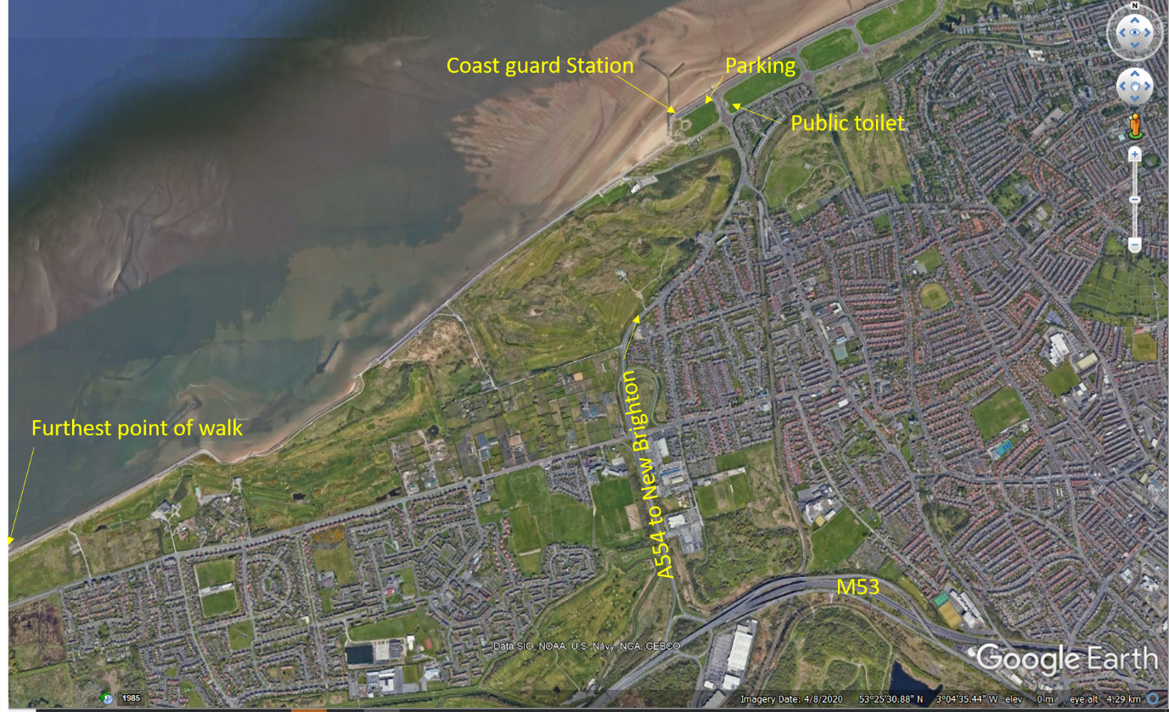
An easy walk (approx. 4 miles) along the sea defences to observe how effective they have been since their installation in the 1970s.
Approximate finishing time 2 pm.
Unknown if public toilets will be available.
Ensuring the health and safety of participants continues to be a priority, so please ensure you have a face mask with you, keep socially distanced and use hand gel. We also ask, if participants are feeling unwell, that they stay at home and get well rather than join the group for this coastal trail.
If you have signed up to join the field excursion, but are unable to make it for any reason, please contact the secretary (07784720551) or field leader (07790680232) so that we are not waiting for you to arrive.
15 places are available. Please contact Maggie Williams via 07784 720 551 or email: lgssecretary19@gmail.com if you wish to reserve a place.
Herefordshire and Worcestershire Earth Heritage Trust
In July 2021 the Trust started their new Lottery-funded partnership project, worth nearly £120,000, on the large glacial erratics in Birmingham and NE Worcestershire. Find out more about this exciting project here:
https://earthheritagetrust.org/birminghams-erratic-boulders-heritage-of-the-ice-age/

The Geological Society
Podcasts: listen to the Geological Society's podcast series produced by Sarah Day, featuring our London lecturers, as well as other geoscientists, speaking about their latest discoveries.
Details from: https://www.geolsoc.org.uk/podcasts

Yorkshire Geological Society
Exploring the Underworld: The geomorphology and sediments of subduction trenches
by Dr Heather Stewart, BGS Edinburgh
Thursday 16th September 2021 | 4.00pm - 5.00pm
Register for this event via: https://www.yorksgeolsoc.org.uk/events-list/exploring-the-underworld

New book: ‘Geology for Walkers’
Members may be interested in knowing about this new book from Steve Peacock.  Steve is a geologist and walker and has written this book as a 'companion for the scientifically curious' - rather than as a textbook. It is aimed at the outdoor enthusiast / hobby geologist interested in learning more about the geological story around them.  Published: April 2021  ISBN: 979-8595445283  Price: £12.65 | 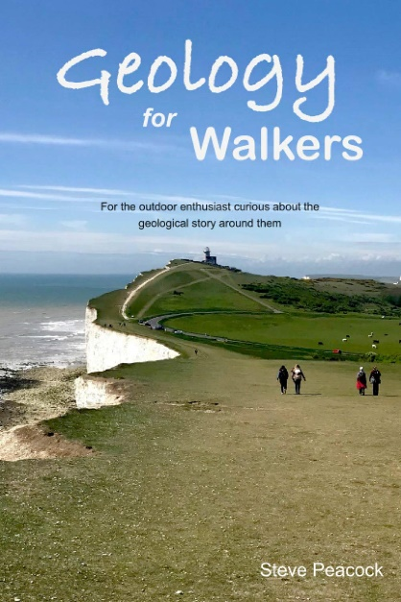 | 