24th September 2021

LGS Newsletter 163.1

Welcome to the 163rd Session of the Liverpool Geological Society!

The programme of meetings for the 163rd session is available at: https://liverpoolgeologicalsociety.org/
Please note:
- This session most of our lectures will be live meetings. Others, at the request of speakers, will be Zoom meetings.
- For 2021, lectures will be held at The Athenaeum and not at Liverpool John Moores University.

Welcome from The Athenaeum
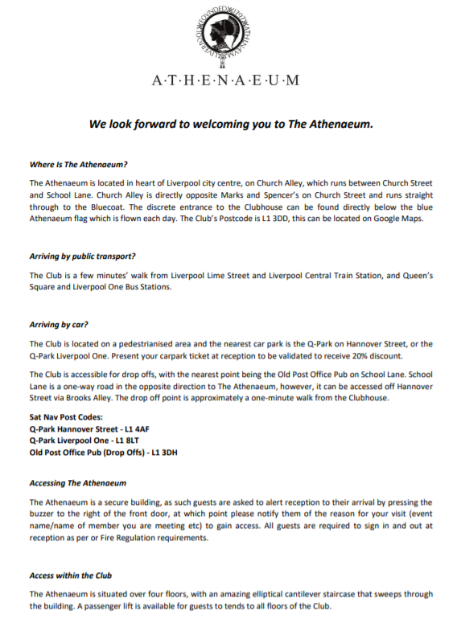

Liverpool Geological Society events
Tuesday 5th October
Presidential address by Dr Alan Boyle (University of Liverpool)
Title: What is Pyrite good for?
Summary: Pyrite typically gets a lot of bad press being associated with death and destruction and being referred to by the somewhat derogatory term “Fool’s gold”. This talk will outline some of the reasons for the widespread dismissal of pyrite, before moving on to discuss some of my research at the University of Liverpool over the last two decades to demonstrate that pyrite is actually a very useful tape recorder of geological processes.

The Liverpool Geological Society Presidential Address will be delivered at The Athenaeum on Tuesday 5th October 2010 at 7.30p.m. by Dr Alan Boyle. Bar facilities and coffee will be available.
Please note: For members reluctant to attend this live meeting, a Zoom transmission of the lecture will be organised. Details about how to access the Zoom meeting will be included in Newsletter 163.2.

Saturday 16th October
Field excursion: Neston Rail cutting
Field Leaders: Jim Marshall and Maggie Williams
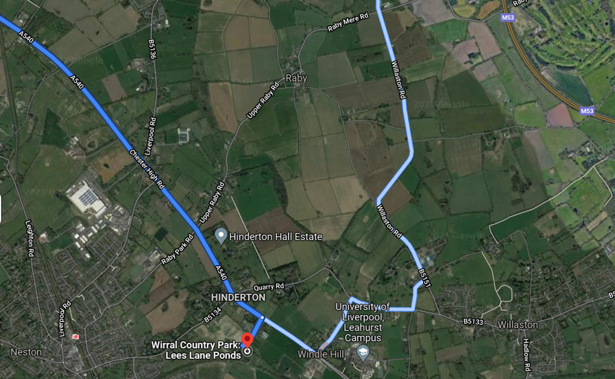
The Neston rail cutting is a Regionally Important Geological Site (RIGS) and this trail is an easy walk along the Wirral Way. The total walking distance will be approximately 1 mile.
Meet at 10 am at the Lees Lane car park* where there is free parking. The approximate finishing time will be 12.30 pm.
*Address: Lees Lane, Neston CH64 7TH
Map reference: SJ 306 776
What three words: obscuring.stretcher.flats
Plus Code: 7XR5+7C Neston

https://goo.gl/maps/ajoP1Arem8aDFdFa8

Please note:
1. Parts of the path can be very muddy and you are advised to wear strong walking shoes or boots.
2. You should wear/carry appropriate clothing for the weather conditions expected at this time of the year.
3. If the weather is very wet, we will not run this excursion.

15 places are available. If you wish to reserve a place on this excursion, please contact Geoff Gilchrist (Excursions Secretary) by email or ‘phone:
Email: gilchristge@gmail.com Mobile: 0789683737354 Telephone: 0151 348 4437
The health and safety of participants continues to be a priority, so please ensure you have a face mask with you, keep socially distanced and use hand gel. We also ask that, if participants are feeling unwell, they stay at home and get well rather than join the group for this event.

Down to Earth Magazine (DTE)
Hard copies of this publication are not being produced because of COVID-19 restrictions, but electronic copies are available, which we have permission to email to LGS members. If you would like a pdf copy of the most recent publications (DTE numbers 115 & 116 and DTE Extra numbers 104, 105 & 106), please email Maggie Williams (Secretary) at lgssecretary19@gmail.com and it will be sent to you.

The North West Geologist
This journal is published jointly by GeoLancashire, Liverpool Geological Society and Manchester geological Association. The Editors are now seeking articles for the next issue of this journal (Issue 22). Prospective authors are asked to contact Dr Graham Sherwood via email: G.J.Sherwood@ljmu.ac.uk
Liverpool Geological Society Prizes 2021
Four prizes were awarded:
Overall excellence in Geography: Scarlett Honour (Liverpool John Moores University)
Overall excellence Geology BSc: Katie Gwynne Hughes University of Liverpool
Overall excellence GPG BSc: Josh Stanley University of Liverpool
Overall excellence Geophysics BSc: Majed Abura University of Liverpool

The Wallace Pitcher Prizes
Tito Santiago Vintimilla Cruz was awarded the 2020-2021 Wallace Pitcher Prize for a piece of work submitted under Category 1: Undergraduate or post-graduate level research paper or dissertation arising from fieldwork by a person based in or attending courses in the Northwest or North Wales for his report entitled ‘The geological evolution and aquifer potential of the northern Cheshire Basin’. In this report, Tito gave a detailed, well-written and well-illustrated account of a fieldwork investigation into the geological evolution and aquifer potential of the northern Cheshire Basin.

From the Treasurer
Subscriptions for the 2021 - 2022 session are due on the 1st October 2021.
Subscription rates are: £15 for full members and £5 for student members (full time students).
Mr Gary T Billington, Honorary Treasurer, Liverpool Geological Society, 4 Lewisham Road, Liverpool L11 1EF
All enquiries regarding membership of the Society or subscription to the Geological Journal should be sent to the Honorary Treasurer at g.t.b_lgs@hotmail.co.uk
Those wishing to take advantage of a Standing Order Mandate to pay their subscriptions and save worrying each year about paying their subscriptions should also contact the Honorary Treasurer, who will supply you our bank details. The Standing Order Mandate can be completed online or by going to your bank in person.

Rock around Port Sunlight
LGS members who were unable to attend the field excursion with Maggie & Peter Williams on Sunday 22nd August 2021 may be interested to know that a copy of the urban geology trail: ‘Rock around Port Sunlight’ is available on the Liverpool Geological Society website.
See: https://liverpoolgeologicalsociety.org/rock-around

Victoria Gallery and Museum, University of Liverpool
LGS members may be interested in the permanent exhibition in the Tate Hall Museum. Step back in time and get hands on with some real fossils. Learn more about ‘Liverpool’s own dinosaur’: vgm.liverpool.ac.uk/exhibitions_events_tours/permanent/fossils/

