30th September 2021

LGS Newsletter 163.2

Programme of Liverpool Geological Society Meetings 2021-2022
Please remember:
For the 163rd Session, lectures will be live lectures or Zoom meetings.
Live meetings will be held at The Athenaeum and not at Liverpool John Moores University.

Liverpool Geological Society events
Tuesday 5th October
Presidential Address by Dr Alan Boyle (University of Liverpool)
Title: What is Pyrite good for?
This lecture, outlined in Newsletter 163.1, will be delivered from the reading room of the Athenaeum Library on Tuesday 5th October 2010 at 7.30 p.m.
The lecture will also be available on Zoom for members who are reluctant to attend this live meeting.
The Zoom login details are available from the LGS Secretary: lgssecretary19@gmail.com
Members wishing to join this Zoom meeting will be able to do so from 7.25 p.m.
Tuesday 19th October
Lecture by Dr Amani Becker, NOC
Title: Energy River: Realising Energy Potential from the Mersey
Summary: As the need for greater renewable energy supply becomes ever more evident, I will present the findings from a review of the potential for increasing renewable energy generation in and around the Mersey Estuary.
Dr Amani Becker will deliver the Liverpool Geological Society Lecture on Tuesday 19th October at 7.30 p.m. on Zoom. To join the Zoom meeting for this lecture, login details are available from the LGS Secretary: lgssecretary19@gmail.com
Members wishing to join this Zoom meeting will be able to do so from 7.15 p.m.

Tuesday 2nd November
Lecture by Steven Millar, Tier Environmental
Title: Geology, Contaminants of Concern and Emerging Contaminants of Concern
Summary: Geology plays an important part in the assessment of the risk to human health and controlled waters when it comes to contaminants of concern that have been used by human activity in the past. However, as one contaminant of concern is no longer used, a new contaminant of concern emerges from the shadows. This talk will provide a brief background to the way geology can help or hinder when contaminants of concerns are identified.

Steven Millar will deliver the Liverpool Geological Society Lecture on Tuesday 3nd November at 7.30 p.m. on Zoom. To join the Zoom meeting for this lecture, login details are available from the LGS Secretary: lgssecretary19@gmail.com
Members wishing to join this Zoom meeting will be able to do so from 7.15 p.m.
Message from the LGS Treasurer
Subscriptions for the 2021 - 2022 session are due on the 1st October 2021.
Subscription rates are: £15 for full members and £5 for student members (full time students).
Mr Gary T Billington, Honorary Treasurer, Liverpool Geological Society, 4 Lewisham Road, Liverpool L11 1EF
All enquiries regarding membership of the Society or subscription to the Geological Journal should be sent to the Honorary Treasurer at g.t.b_lgs@hotmail.co.uk
Those wishing to take advantage of a Standing Order Mandate to pay their subscriptions and save worrying each year about paying their subscriptions should also contact the Honorary Treasurer, who will supply you our bank details. The Standing Order Mandate can be completed online or by going to your bank in person.

Manchester Geological Association (MGA) events
Saturday 13th November 2021 Broadhurst Lectures Day
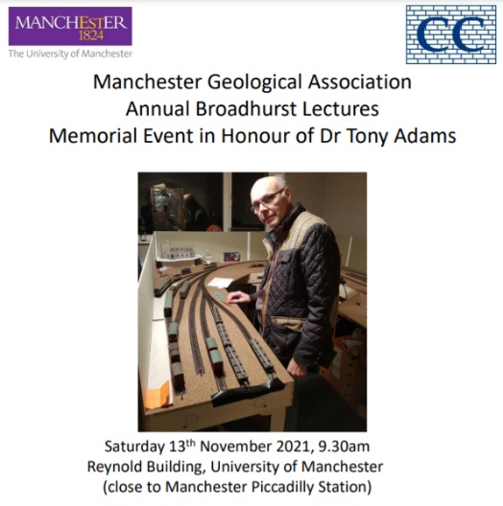 | 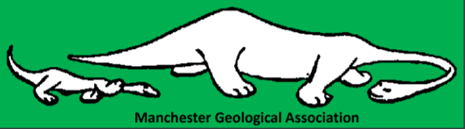  This event is free, but you need to register to attend.  Register here:  https://docs.google.com/forms/d/e/1FAIpQLSdoUCJm8eIiivrISPo6T6lKrM3ejDLa6jpII2S0cwtVw8Jpwg/viewform

If you visit the MGA website: http://www.mangeolassoc.org.uk/newsletter.php you can download a copy
of the March 2021 Newsletter. This includes an article by Niall Clark: ‘Borehole Geology and Public Water Supplies’, which is an edited down version of the Presidential Address made to the 2021 AGM.
The newsletter also includes an article by Fred Owen: ‘Sandstone Retaining Wall Awarded Scheduled Monument Status by Historic England’.

More information about this sandstone wall is available at:
https://historicengland.org.uk/listing/the-list/list-entry/1470478

Yorkshire Geological Society (YGS)
Thursday, 28 October 2021 16:00-17:00
Lecture by Prof Cynthia Burek (University of Chester)
Title: The history of Geoconservation: the Cinderella conservation science
More information about this event is available at:
https://www.yorksgeolsoc.org.uk/events-list/the-history-of-geoconservation-the-cinderella-conservation-science

