16th November 2021

LGS Newsletter 163.4

Programme of Liverpool Geological Society Meetings 2021-2022
For the 163rd Session, lectures will be live lectures or Zoom meetings.
Live meetings will be held at The Athenaeum and not at Liverpool John Moores University.

Liverpool Geological Society events
Tuesday 23rd November
Lecture by Professor Richard Worden, University of Liverpool
Title: Carbon capture and storage: why we need it, what it is and what is holding it up How resilient will the
Summary: Carbon capture and storage (CCS) is a strategy designed to cut emission of the greenhouse gas: carbon dioxide. Carbon (dioxide) emissions result from practically all human activity from farming, through to cement manufacture, steel and other metal manufacture, as well as electricity, heat and power generation by burning fossil fuels. Carbon emissions must be cut to avoid catastrophic global warming which will otherwise result in sea-level rise by metres, loss of farmland, drowning of coastal cities, contamination of precious fresh water, changing global weather patterns, increased storminess and all the attendant human disasters that will result from any one of these consequences.
A major problem is that countries, corporations, and individuals are unwilling to change the way they function and live and are reluctant to face up to the long-term consequences of today’s actions. Note carefully, this is not just a question of building a few windfarms or even a few more nuclear power stations as cement, steel, and farming account for a massive proportion of carbon emissions. Carbon capture and storage is designed to help, though, by collecting CO₂ from industrial point sources of generation such as power stations, and cement and steel factories, and injecting it deep underground, to be locked up forever.
Sound simple? In some ways it is, but there are serious factors holding up large-scale adoption of CCS. The good news is that there are precedents from a few oil and gas production companies that have already injected separated CO₂, naturally present in some oil and gas fields, back into the sub-surface, over a period of 60 years or more. What is needed now is on a wholly different scale: all globally produced industrial CO₂ must be separated from exhaust gas streams and piped or shipped to CCS sites.
In this talk we will cover some of the background but focus on the geology of carbon capture. We will also focus on the factors inhibiting large-scale adoption of CCS such as who insures, or assures, these projects designed to last for 10’s to 100’s of thousands to years, who pays for the very expensive capital and then never-ending operating costs for CCS. We may also touch on possible public resistance to CCS given that it will almost certainly cause micro-earthquakes, like shale-gas exploitation.
Biography:
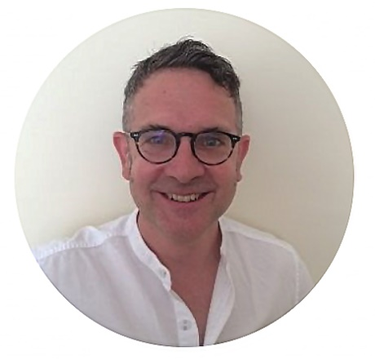 | Richard was born in Blackpool in 1962. In 1984 he graduated from Manchester University with a bachelor’s degree in geochemistry and then attended Manchester University to study for a PhD in geology, graduating in 1988. After working as a post-doctoral researcher at Edinburgh University and then as a geologist/geochemist for BP Research at Sunbury on Thames, Richard joined Queen’s University, Belfast as a geology lecturer. From 2000 Richard has worked at the University of Liverpool as a geology professor.  Those conversations led to the suggestion for the presentation today.
Richard’s research areas include, amongst other topics, carbon capture and storage (as you will hear), and the comparison of modern sedimentary environments to ancient and deeply buried sedimentary rocks. The latter topic has involved Richard and his team working in the Ravenglass Estuary since about 2008 and has involved months of intensive field work (sampling, mapping etc), drilling a series of geotechnical cores right through the post-ice age estuarine sediment right through to the underlying sticky glacial till and the study of Ravenglass sediment using a wide range of techniques. Various organisations and individuals based in Cumbria have proved to be very helpful over the last year to Richard’s research efforts in deducing the way that the channels in the Ravenglass Estuary have evolved since the last ice age. Those conversations led to the suggestion for the presentation today.
Note that Richard is happy to give a talk on his Ravenglass work later in the year.
Richard Worden will deliver the Liverpool Geological Society Lecture at The Athenaeum on Tuesday 23d November at 7.30 p.m. Bar facilities and coffee will be available.
Members wishing to visit The Athenaeum for this lecture will be able to do so from 6.30 p.m.

Please note: Members and visitors who wish to connect to the Zoom transmission of the lecture should contact Maggie Williams (LGS Secretary) for details about how to access the Zoom meeting: lgssecretary19@gmail.com
Members and visitors wishing to join this Zoom meeting will be able to do so from 7.25 p.m.

LGS Fieldwork follow-up
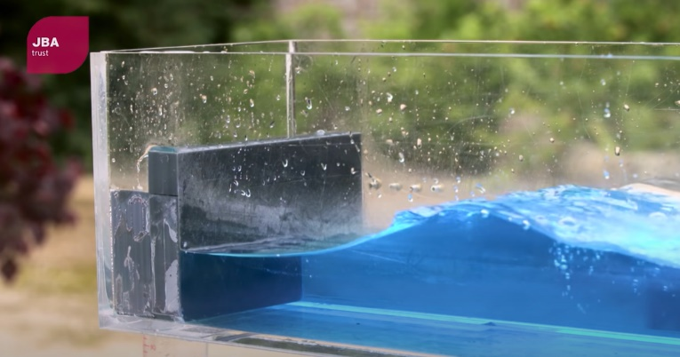 | Following the field excursion on Saturday 4th September 2021 to look at the Wirral coastal defences from Kings Parade to Leasowe Bay, members may be interested to visit the following site where there is a wave tank demonstration showing the impact of coastal defences on flood risk:  https://www.youtube.com/watch?v=3yNoy4H2Z-o
Down to Earth Magazine (DTE)
Hard copies of this publication are not being produced because of COVID-19 restrictions, but electronic copies are available, which we have permission to email to LGS members. If you would like a pdf copy of the most recent publication (DTE Extra number 107), please email Maggie Williams at: lgssecretary19@gmail.com

Geologists Association (GA)
The GA’s ‘Geology from your Sofa’ (GFYS) website has been updated. For details of a range of virtual field trips, geology courses, events, and activities visit:
https://geologistsassociation.org.uk/sofageology/

Yorkshire Geological Society (YGS)
Yorkshire Geological Society Circulars
The YGS Circular Archive, which includes circulars dating back to 2003 may be found on the new YGS website: https://www.yorksgeolsoc.org.uk/circulars

North East Geological Society
Friday 26th November 2021 7.30 – 8.30p.m.
Lecture by Prof Alexander Peace, McMaster University, Canada
Title: Volcanic Passive Margins
Register for this free virtual lecture via the Eventbrite link: https://www.eventbrite.co.uk/e/168211520185

Geological Society of London
Thursday 9th December 6.00-7.15 p.m. Virtual lecture by Carole Haswell (Head of Astronomy, OU)
Title: Rocky planets across the galaxy
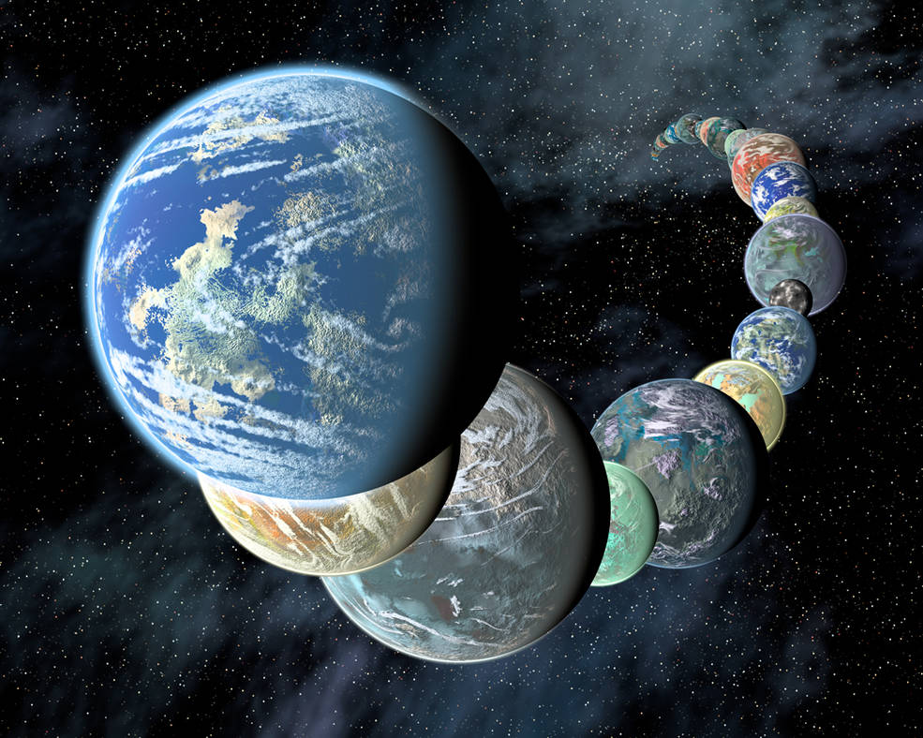 | Artist’s concept of how rocky, potentially habitable worlds elsewhere in our galaxy might appear.  (Placing them so close together in a line is for illustrative purposes only!)  Credits: NASA/JPL-Caltech/R. Hurt (SSC-Caltech)

Summary: The context for our understanding of Earth and the other rocky bodies in the Solar System planets changed dramatically with the discovery in 2009 of CoRoT-7b, the first potentially terrestrial exoplanet. Many more probable rocky exoplanets have been discovered by the Kepler mission, showing that rocky planets are common in our Galaxy. There are likely to be more planets than stars in the Galaxy, and most of these planets are significantly smaller than Neptune.
Register for this virtual lecture via:
https://www.eventbrite.co.uk/e/rocky-planets-across-the-galaxy-tickets-166486779439

Herdman Society
Saturday 12th February 2022 Herdman Symposium
The theme will be Impacts of Geoscience and the event will run in a hybrid online and in-person format.
Remember to save this date in your diary.

