21stNovember 2021

LGS Newsletter 163.5

This is the last LGS Newsletter for 2021.  Sending you best wishes for Christmas and New Year and looking forward to meeting you all in 2022. | Photo by Lum3n from Pexels
Liverpool Geological Society events
Tuesday 30th November
Lecture by Tom Sharpe
Title: Mary Anning: monsters, myths, and misfortunes.
Summary: It has been said that more has been written about Mary Anning, the fossil dealer of Lyme Regis, than about any other geologist, apart from Charles Darwin. But how much do we really know? How much is speculation? And how much is myth that has developed through the uncritical telling and retelling of her tale over the course of two centuries? Separating the facts from the fictions about Mary Anning can be challenging, but her story is a remarkable tale. This talk will examine what we know of the life of this extraordinary woman, her famous - and less well-known - discoveries, and her part within the wider network of the developing science of palaeontology in the early nineteenth century and will seek to dispel at least a few of the Mary myths.
Biography:
Tom Sharpe FGS is a geologist, expedition travel guide and former Chair of the History of Geology Group (HOGG).  He is also author of ‘The Fossil Woman: A Life of Mary Anning’.  HOGG was inaugurated in October 1994 to encourage interest in the lives and work of those scientists and philosophers who influenced both the study and the practice of geology. |  | 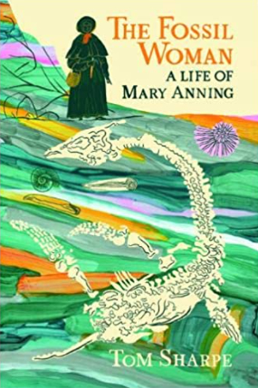

Tom Sharpe will deliver the Liverpool Geological Society Lecture on Tuesday 30th October at 7.30 p.m. on Zoom. To join the meeting for this lecture, please contact the Secretary via email: lgssecretary19@gmail.com to get the login details.
Members wishing to join this Zoom meeting will be able to do so from 7.15 p.m.

Tuesday 7th December 6.30 – 9.00 p.m.
Practical in the Central Teaching Laboratories, University of Liverpool
Arranged by Maggie & Peter Williams
Title: Jelly volcanoes
Outline of activity:  Direct observation of physical processes in the Earth’s crust can be challenging and comes with its own set of limitations. Laboratory modelling allows scientists to model, observe, and reproduce complex  processes in a safe and controlled environment.  In this practical you will carry out an analogue experiment to model how volcanic eruptions are fed by magmatic intrusions. You will be able to make key observations about surface deformation, the evolution of internal stresses and the geometry of intrusions. | 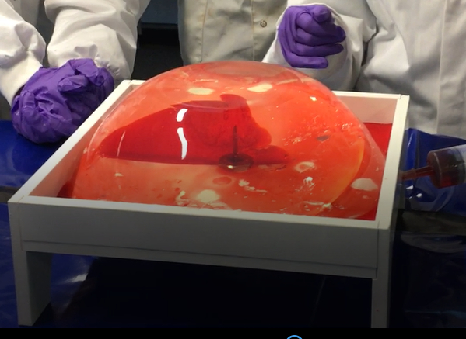

Please note: Only 12 places are available for this session. Please contact Maggie Williams by mobile: 07784 720 551 or email: lgssecretary19@gmail.com if you wish to reserve a place.

Four benches will be set up with equipment for this experiment and on each bench a group of three people will work together to carry out the experiment. Lab coats and protective gloves will be provided.

Ensuring the health and safety of participants continues to be a priority, so please make sure you have a face mask with you, keep socially distanced and use hand gel. We also ask, if participants are feeling unwell, that they stay at home and get well rather than join the group for this practical session. If you have booked a place for this session, but are unable to make it for any reason, please contact the secretary on 07784720551 or via email lgssecretary19@gmail.com so that we are not waiting for you to arrive.

Meet at 6.25p.m. in the foyer of the Central Teaching Laboratories, University of Liverpool, Liverpool, Merseyside, L69 7BX.
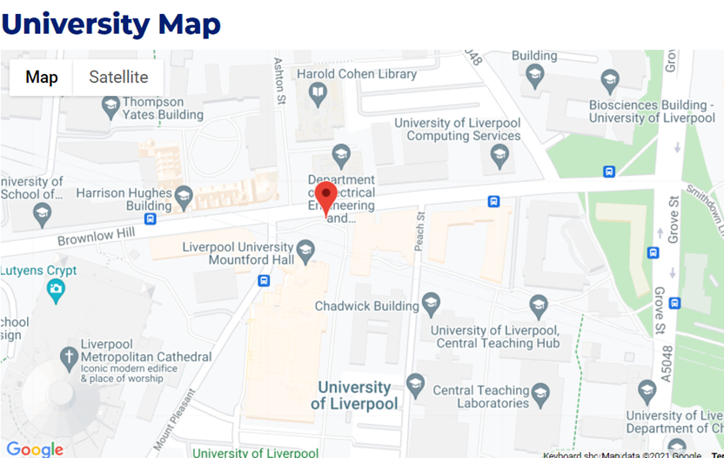

Tuesday 14th December
Lecture by Dr Bill Wimbledon, Bristol University
Title: How to place a Golden Spike: a cautionary tale from the Jurassic/Cretaceous boundary
Summary: The only system in the Phanerozoic for which a base has not been agreed is that for the Cretaceous. That base lies at the bottom of the Berriasian, the first stage/age of the Cretaceous System/Period at about 140 million years ago. Reasons for that lack of a resolution are various, ranging from problems of correlation due to biotic provincialism, low biodiversity, isolated marine areas, and widespread non-marine facies, and discussions that have sometimes been spiced with nationalism and rivalries.
In fact, the first J/K sedimentary rocks described were in the UK, in the Portland and Purbeck beds of England and northern France. Victorian geologists always regarded both as Jurassic, what today would be called Tithonian. It was only in the 1980s that magnetic evidence indicated that the J/K boundary lies within the Purbeck beds, not above. This is a formation famous for its myriad insects, mammals, pterosaurs, turtles, crocodilians etc., but it is not a source of the kinds of marine biota useful for wider correlation, such as ammonites. Therefore, the positioning of a J/K boundary in the UK has never been much discussed. Other regions like China and interior USA share the same problems – abundant dinosaurs (some furry), molluscs, insects etc., but no marine fossils. Radiometric dates have come recently to these regions, and these help a little.
In marine basins away from the equator (“boreal” and “austral” regions) there are fossiliferous sediments, but the fossil content is limited in its usefulness for correlation. Fossils are sometimes super abundant, but never diverse; and the ammonites, benthic molluscs, dinoflagellates, radiolaria, belemnites etc. that are present tend to be limited to higher latitudes, rarely extending into more equatorial waters and the former great ocean of Tethys. With its many sites that yield the richest marine biotas and where most studies have occurred. Previous discussions and the decisions of international symposia have consistently agreed that the Global Stratotype Section and Point (GSSP) for the Berriasian should be located in an outcrop in the sedimentary rocks of Tethys.
Discussions in past decades on Mesozoic stage boundaries, including the J/K boundary, were always dominated by ammonite specialists; and on the J/K it had a rather narrow geographical focus – ammonite correlation between Mediterranean Tethys and boreal Russia being a paramount preoccupation. Even though correlative accuracy with this was poor, sometimes with discrepancies of more than 2 my(!). Subsequently, widespread endemism in the ammonites had been increasingly recognised as an obstacle to correlation, even in the regions of Tethys, and, thus, though published research on the J/K interval has grown and more profiles have been documented, it has been done relying less and less on ammonites, and more on ubiquitous calpionellids combined with magnetostratigraphy.

Bill Wimbledon | Dr Bill Wimbledon will deliver the Liverpool Geological Society Lecture at The Athenaeum on Tuesday 14th December at 7.30 p.m. Bar facilities and coffee will be available.  Members wishing to visit The Athenaeum for this lecture will be able to do so from 6.30 p.m.  Please note: To join the Zoom transmission of this lecture, please contact the Secretary via email: lgssecretary19@gmail.com to get the login details.  Those wishing to join this Zoom meeting will be able to do so from 7.15 p.m.

Messages from the LGS Secretary
- All Saints, Childwall: Gravestone geology
Merseyside Archaeological Society has been conducting a graveyard survey at All Saints Childwall since 2009. Last year the Society won an award to have the gathered data published on the Discovering England's Burial Sites website. To date, about a third of the oldest monuments have been published:
https://archaeologydataservice.ac.uk/archives/view/1003999/
The Society is currently finalising the submission of the remainder of the data. Peter Williams and Maggie Williams have done some work to help, but the organiser is hoping to expand the project in the New Year and wishes to recruit additional volunteers to look at different aspects of the graveyard and its history. If there is anyone from the Society who would be interested in looking more deeply into the geology and provenance of the gravestones, they would be most welcome.
If you are interested in finding out more, please email Maggie Williams via lgssecretary19@gmail.com
- A Golden Spike
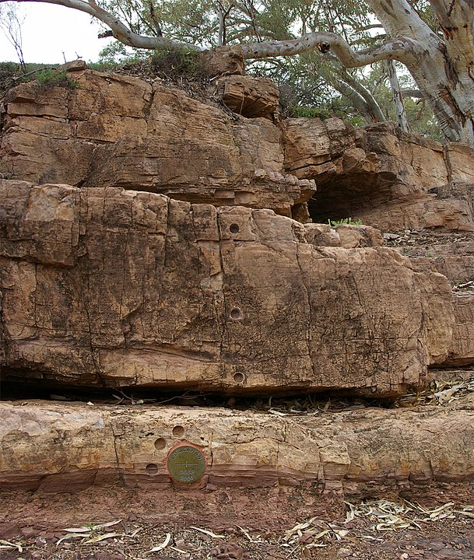 | Did you know that a golden spike is a special geologic marker?  This photograph shows the 'golden spike' (bronze disk in the lower section of the image) of the Global Boundary Stratotype Section and Point (GSSP) for the Ediacaran period, located in the Flinders Ranges in South Australia.  Credit: Peter Neaum at English Wikipedia, CC BY-SA 3.0  Note: The core holes shown at this locality were made to study changes in the Earth's magnetic field.
If you are interested to find out more, a list of Global Boundary Stratotype Sections and Points (GSSPs) is available here: https://en.wikipedia.org/wiki/List_of_Global_Boundary_Stratotype_Sections_and_Points

