17th December 2021

LGS Newsletter 163.6

Liverpool Geological Society events
Tuesday 4th January 2022
Members’ Evening at The Athenaeum
Stephen Hurrell “Quetzalcoatlus northropi in a reduced gravity”
Aeronautical calculations seem to show that the largest pterosaurs would struggle to achieve powered flight. Is it possible that these Cretaceous giants flew in a reduced gravity?

Geoff Gilchrist “Llangollen”
The area covered is based on the 1: 50 000 BGS map sheet 121 (Wrexham): Solid & Drift map. The geology ranges from Ordovician to post glacial. There is a strong relationship between the geology and the physical landscape with some unique features. The Carboniferous outcrops and associated landscape features are quite dramatic and some of the post glacial features such as glacial diversions involving deeply incised meanders are unique.

Peter Williams “Kicking a can in Kitkiojarv”
A talk about one of the oldest objects in the solar system – and one of the youngest. And for those that like a puzzle, here are 4 dates for you:
4.56 billion years ago
1 000 000 years ago
1906
February 2021

Please note: This will be live meeting. Members wishing to visit The Athenaeum for this lecture will be able to do so from 6.30 p.m. A Zoom transmission of these talks has not been arranged.
LGS Meetings from 11th January 2022
- Lectures will be held in the Central Teaching Hub, University of Liverpool and not in The Athenaeum.
- Most of our lectures will be live meetings. Others, at the request of speakers, will be Zoom meetings.

Location of the Central Teaching Hub:
University of Liverpool, Central Teaching Hub, Liverpool, Merseyside, GB, L69 7BX
The Central Teaching Hub is Building 221 on the map below.

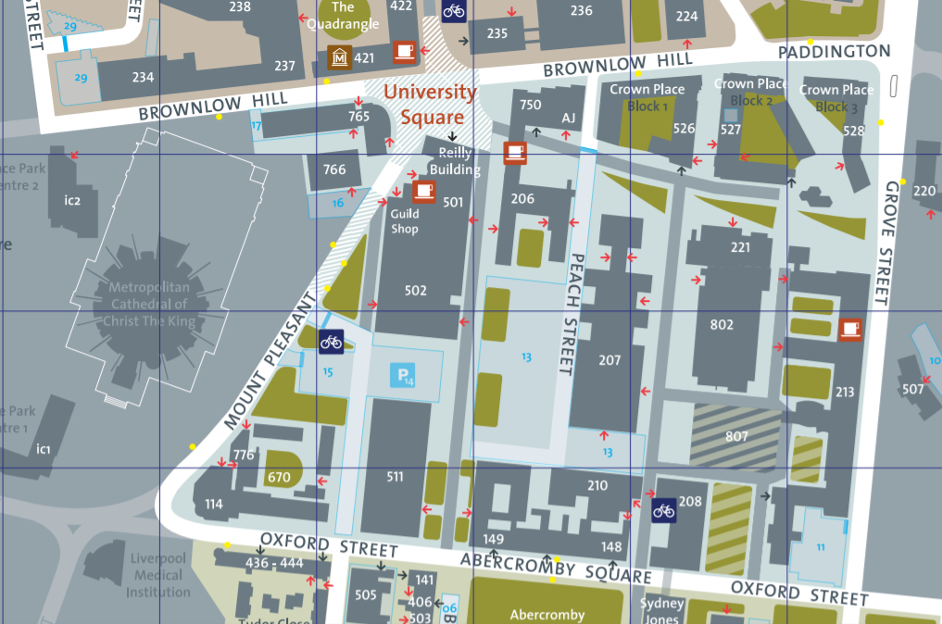
For further details of the University of Liverpool campus see the campus go to:
https://www.liverpool.ac.uk/media/livacuk/maps/Campus,Map,2020_0903.pdf

Arriving by car
There is a site/campus car park for staff, students, and visitors within approximately 200m. It is shown by the blue parking symbol on the above map.
The name of this car park is Mount Pleasant Car Park.
The car park is located off Mount Pleasant, to the rear of the Sports Centre (building 511).
Note: Limited on-street parking is available in Crown Street.

Arriving by public transport
Rail
The Campus is a ten-minute walk from the nearest mainline station at Lime Street.
Take the main exit and turn left into Lime Street. Then turn left again at the Britannia Adelphi Hotel and continue up Brownlow Hill towards the Metropolitan Catholic Cathedral and Red Brick Building with its clock tower. Cross the road into University Square and use the above map to find the Central Teaching Hub.
Note: Use the Merseyrail website or National Rail Enquries to plan your journey.

To access the Central Teaching Hub
Please use the entrance to the Central Teaching Laboratories (building 802 on the map). This entrance is opposite the entrance to the Chadwick Building (building 207).
A sign in the foyer will show you which lecture theatre we will be using.
University of Liverpool, Liverpool, Merseyside, L69 7BX. 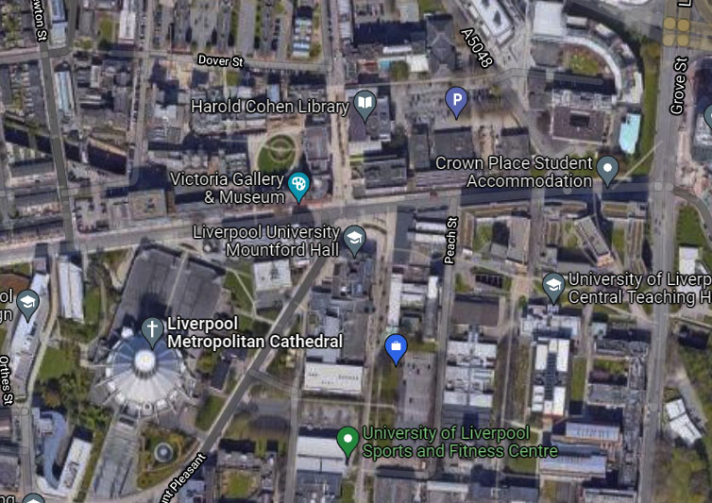

Chadwick Building USE THIS ENTRANCE
Meetings in the Central Teaching Hub will start at 7.30 p.m.

Tuesday 11th January 2022
11th January 2022
Lecture by Professor Peter Burgess (University of Liverpool)
Title: “My Favourite Outcrops and the Tales They Tell”

Outcrops can tell a wonderful story of Earth history, and this talk will discuss a few favourite examples I have visited to do field work, from North America to South Wales and across a range of geological ages and events.

Members wishing to visit the Central Teaching Hub for this lecture will be able to do so from 6.30 p.m.

Please note: For members reluctant to attend this live meeting, a Zoom transmission of the lecture will be arranged. To join the Zoom meeting for this lecture, please email the LGS Secretary via: lgssecretary@gmail.com
Members & visitors wishing to join this Zoom meeting will be able to do so from 7.15 p.m.

