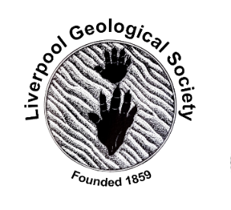 | 16th January 2022  LGS Newsletter 163.7

Sad news
It is with great sadness that we wish to report that Hilary Davies died in hospital on New Year's Eve after a long illness.
Hilary’s funeral will be at 11.20 on 1st February at Chester Crematorium. It has been suggested that no more than 33 people attend while current guidelines are in place, and we understand that nearly all the 33 places have been taken.

Please do not send gifts or flowers. Alun has suggested that donations in Hilary's memory may be made to the Yorkshire Dales Millennium Trust: https://www.ydmt.org/

If anyone would like to send memories and condolences to Alun he is happy to receive them at home. Please contact the secretary, lgssecretary19@gmail.com, for the address.

Liverpool Geological Society events
LGS Meetings during 2022
- Lectures will be held in the Central Teaching Hub, University of Liverpool and not in The Athenaeum.
- Most lectures will be live meetings. Others will be via Zoom. Meetings will start at 7.30 p.m.
Location of the Central Teaching Hub:
The Central Teaching Hub (University of Liverpool, Merseyside, L69 7BX) is Building 221 on the map below:
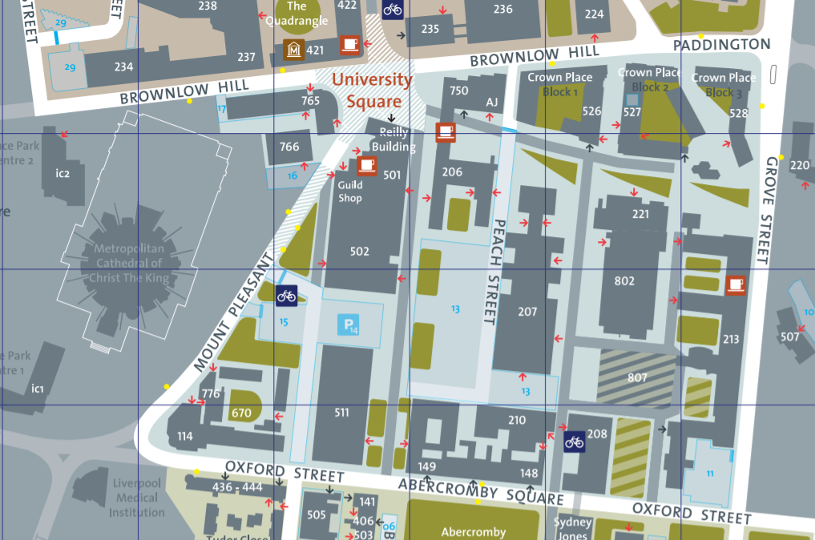
Campus map: https://www.liverpool.ac.uk/media/livacuk/maps/Campus,Map,2020_0903.pdf

Entrance will be via the side door:
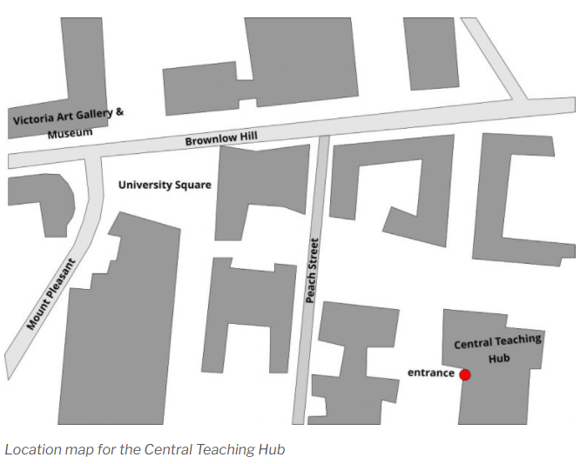
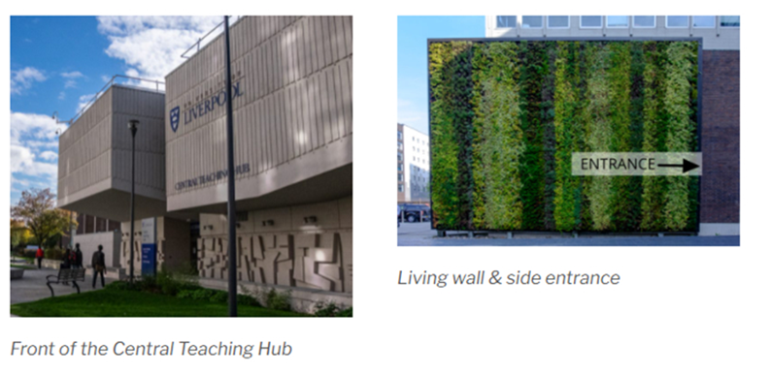
Tuesday 25th January 2022
At 7.30 p.m. in Lecture Theatre D, Central Teaching Hub.
Lecture by Professor Andy Plater (University of Liverpool)
Title: “Reconstructing barrier beach and lagoon response to El Nino using particle size data”

This talk bridges timescales of geomorphic processes and  records of environmental change by exploring the  inter-annual behaviour of coastal barrier systems on the California coast.  Data on particle size distributions from saltmarsh sediments are used to examine variability in wave climate and rainfall in determining system disturbance and recovery.  Andy is a coastal geomorphologist with a keen interest in reconstructing system response to changes in sea-level,  sediment supply and extreme events (storms and high  rainfall). Most of his work focuses on sedimentary archives  of environmental change, and what can be determined  from these archives in terms of environmental forcing,  response and recovery, human impact and sediment  provenance. His work also links to the application of  modelling and monitoring to detect, characterize and  predict coastal change for climate change adaptation. | 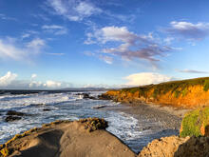  Coastlines at Pescadero, California. Photo: Meaghan Faletti, USGS, Public domain.  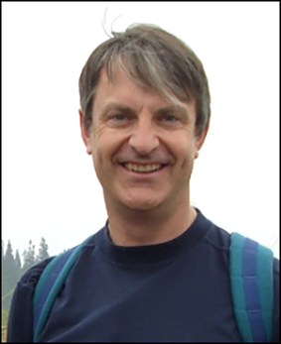
Members wishing to visit the Central Teaching Hub for this lecture will be able to do so from 6.30 p.m.
Please note: For members reluctant to attend this live meeting, a Zoom transmission of the lecture will be arranged. To join the Zoom meeting for this lecture, please email the LGS Secretary via: lgssecretary@gmail.com
Members wishing to join this Zoom meeting will be able to do so from 7.15 p.m. The lecture will start at 7.30 p.m.

Down to Earth Magazine (DTE)
Hard copies of this publication are not being produced because of COVID-19 restrictions, but electronic copies are available, which we have permission to email to LGS members. If you would like a pdf copy of the most recent publications (DTE Extra number 107, 108 and 109), please email Maggie Williams at: lgssecretary19@gmail.com

Geologists Association (GA)
GA Video Lectures
These are normally only available to GA Members but for the duration of the Covid-19 lockdown, they will be freely available to all interested in geology via this link: https://geologistsassociation.org.uk/galecturesforall/
GA Lectures 2022
For details of these hybrid meetings, visit: https://geologistsassociation.org.uk/lectures/
Geology from your Sofa (GFYS)
The GA’s ‘Geology from your Sofa’ (GFYS) website has been updated. For details of a range of virtual field trips, geology courses, events, and activities visit: https://geologistsassociation.org.uk/sofageology/

North East Geological Society
Friday 28th January 2022, 7:30p.m.
Lecture by Edgardo Cañón-Tapia, CICESE (Division de Ciencias de la Terra, Ensenada, Baja California, Mexico)
Title: ‘Spatial distribution of volcanic vents and their relation with the plumbing system’
You need a link to access this lecture, which can be obtained from Huttonsedgewick@gmail.com
Please don't leave it until the last minute!

Northumberland Wildlife Trust
To the end of March 2022, the Northumberland Wildlife Trust is running an online programme on the rocks of the traditional county of Northumberland to mark its 50th anniversary. This features 50 geological sites, some familiar other less so, of general interest to the wider public.
Full details at: http://nwt.org.uk/rock-festival-sites

Yorkshire Geological Society (YGS)
Thursday, 17th February 2022, 4.00 - 5.00p.m.
Webinar by Professor Steve Brusatte (School of GeoSciences, University of Edinburgh)
Title: ‘The rise and fall of the dinosaurs’
Register for this event via: https://www.yorksgeolsoc.org.uk/events-list/the-rise-and-fall-of-the-dinosaurs

Yorkshire Geological Society Circulars
The YGS Circular Archive, which includes circulars dating back to 2003 may be found on the new YGS website: https://www.yorksgeolsoc.org.uk/circulars

Wirral History and Heritage Fair
Saturday 12th March 2022, 10.00a.m. – 4.00p.m.
This free event will be held at Hulme Hall, Bolton Road, Port Sunlight, Wirral, CH62 5DH.
Jim Marshall launched 'Wirral Geology and Landscape Project' at the last Fair at Birkenhead Town Hall where his stall attracted several hundred people. Please come and visit Jim’s stall and share your enthusiasm for local Geology and the LGS.
Contact Jim Marshall if you want more information, or can offer to help for all or part of the day:
jimmarshall58@gmail.com
For further information about the Wirral History and Heritage Association visit the WHHA website: https://sites.google.com/site/wirralhha/next-whha-event

New book coming soon
Roy Starkey has been working on a biography of the British mineralogist Sir Arthur Russell (1878-1964). He is hopeful that the book “Making it mine - Sir Arthur Russell and his Mineral Collection” will be published during the first half of 2022. The book explores the fascinating story of Sir Arthur Russell 6th Baronet as he pursued his quest to build the finest collection of British minerals ever assembled.
Learn more about the project: https://britishmineralogy.com/wordpress/?page_id=1034

