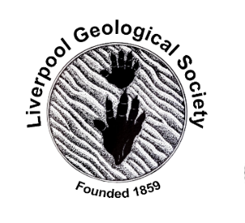 | 29th January 2022  LGS Newsletter 163.8

Liverpool Geological Society events
Tuesday 8th February
At 7.30 p.m. in lecture theatre D, Central  Teaching Hub.  Lecture by Dr. Greig Paterson (University of  Liverpool)  Title: “The magnetic personality of bacteria”  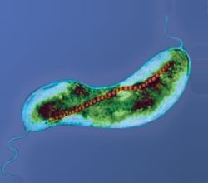  An example of a magnetotactic bacteria  showing magnetosome. CC BY-SA 3.0 | 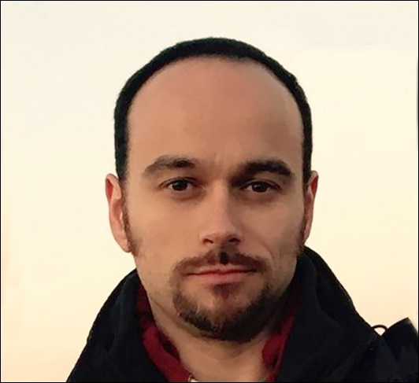  Greig Paterson is an Independent Research Fellow and Lecturer in Geophysics at the University of Liverpool. His work focuses on the broad applications of magnetism to understand Earth evolution and life.  Greig will be presenting ideas old and new on magnetotactic bacteria (MTB). These microscopic organisms mineralize magnetic particles within their cells, which are aligned in a chain and act like a tiny magnetic compass. MTB have existed for most of Earth’s history and Greig will talk about some of the implications of these ancient magnetic navigators.
Members wishing to visit the Central Teaching Hub for this lecture will be able to do so from 6.30 p.m.

Please note: For members reluctant to attend this live meeting, a Zoom transmission of the lecture will be arranged. To join the Zoom meeting for this lecture, please email the LGS Secretary via: lgssecretary@gmail.com

Members wishing to join this Zoom meeting will be able to do so from 7.15 p.m. The lecture will start at 7.30 p.m.

Tuesday 22nd February
At 7.30 p.m. in lecture theatre D, Central Teaching Hub.  Lecture by Dr. Alan Thompson (Cuesta Consulting)  Title: “Karstic landscapes of England and Wales: The Good, the (not so) Bad and the Ugly”  This talk will cover three very different examples of the landscapes and processes associated with karst – the natural dissolution of soluble rocks by flowing groundwater. The “Good” will be represented by the limestone pavements and other features in the Arnside and Silverdale Area of Outstanding Natural Beauty, and adjoining parts of North West England. The “Not so Bad” relates to a proposal to extend a limestone quarry, in South Wales, into a geological Site of Special Scientific Interest characterised by an area of spectacular ‘interstratal’ dolines. The “Ugly” relates to the rapid dissolution of gypsum deposits, rather than limestone, and the associated problems of subsidence in the city of Ripon in North Yorkshire. | 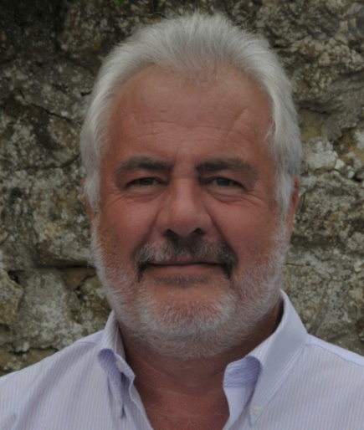
Members wishing to visit the Central Teaching Hub for this lecture will be able to do so from 6.30 p.m.
Please note: For members reluctant to attend this live meeting, a Zoom transmission of the lecture will be arranged. To join the Zoom meeting for this lecture, please email the LGS Secretary via: lgssecretary@gmail.com

Members wishing to join this Zoom meeting will be able to do so from 7.15 p.m. The lecture will start at 7.30 p.m.

General advice to people visiting the University of Liverpool
- Social distancing requirements across campus are to be removed in all indoor spaces from 31st September 2022.
- Face coverings are strongly encouraged in all indoor spaces on campus, including teaching areas.
- Visitors are expected to test negative before coming onto campus and are encouraged to continue to follow basic personal hygiene measures e.g. regular handwashing, sanitising etc.

Down to Earth Magazine (DTE)
Hard copies of this publication are not being produced because of COVID-19 restrictions, but electronic copies are available, which we have permission to email to LGS members. If you would like a pdf copy of the most recent publication (DTE Number 118, published February 2022), please email Maggie Williams at: lgssecretary19@gmail.com

Herdman Symposium 2022

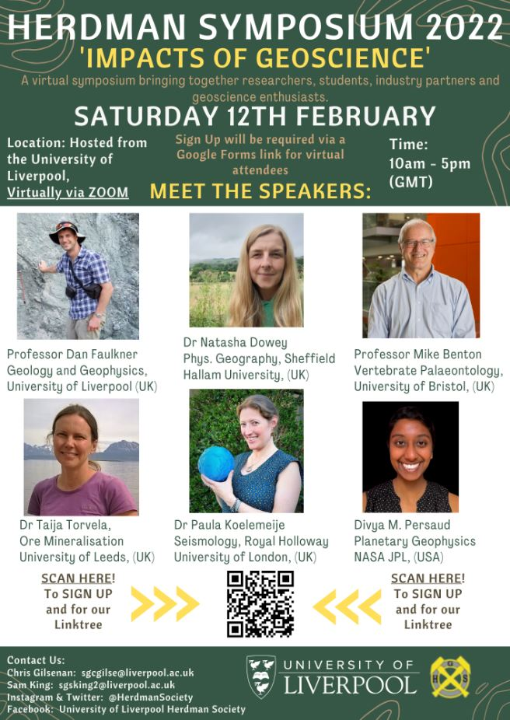

Geologists Association (GA)
The GA is pleased to invite you to attend our next Virtual Zoom Workshop on Friday 18th March 2022 @ 7:30pm
This workshop will be led by Dr Tom Hose, Dr Jonathan Larwood and a local group representative.
The workshop will explore the value of geological archives and encourage discussion between local groups that have either embarked upon, or are considering doing so, the task of archiving their information (minute books, newsletters, field notebooks, photographs etc.). It is hoped that members of local geology groups will both learn from this workshop and share their experiences. It will discuss the actual records; both physical and electronic, share experiences of archive management, and introduce examples of archiving principles and practices.
The workshop will take the form of short talks follow by discussion.
Talk 1: GA Carreck Archive – example of a success story and the value of a geological archive, including archive conservation, digitisation, and presentation.
Talk 2: Principles and Practices – types of archive material; mechanics (with a focus on low-cost solutions) of copying and digitizing archives; digitized archive standards, access and future proofing.
Talk 3: Local Group example – What worked well, what didn’t, effort involved, future plans.
Details on how to join the virtual meeting will be communicated to participants upon booking.
https://geologistsassociation.org.uk/ukfield/

Yorkshire Geological Society (YGS)
Thursday, 17th February 2022, 4.00 - 5.00p.m.
Webinar by Professor Steve Brusatte (School of GeoSciences, University of Edinburgh)
Title: ‘The rise and fall of the dinosaurs’
