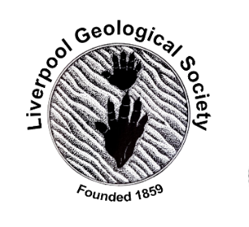 | 19th February 2022  LGS Newsletter 163.9

Liverpool Geological Society events
Tuesday 8th March
Extraordinary Meeting
This meeting will begin at 7.30 p.m. and will precede the lecture by Professor Chris Hunt.
Agenda for the Extraordinary Meeting
- Amendment to the Constitution of the Liverpool Geological Society.
The following amendment to section 12.1.1 of the LGS Constitution is proposed by Council:
12.1.1 Monetary awards may be made annually to a present or immediate past student of The
University of Liverpool, The Liverpool John Moores University, Edge Hill University and Liverpool Hope
University, for special academic achievement in geology and/or related science(s).
2. Nominations for Council 2022 – 2023.
The following are proposed by Council to be elected for the 2022/2023 Session:
Officers of Council:
President M Amlôt, Vice-President, P. Burgess, Hon Secretary ME Williams, Hon Assistant Secretary HE Clark, Hon Programme Secretary NC Hunt, Hon Treasurer GT Billington, Hon Assistant Treasurer NC Hunt, Hon Editor (NW Geologist) G Sherwood, Hon Librarian WJ Iley, Hon Archivist A Morgan, Hon Publicity Officer S Hurrell, Hon Excursions Secretary G Gilchrist, Hon Website Manager TJP Williams, Hon Publications Sales Manager GT Billington.
Ordinary Members of Council:
J Brinkley, R Leong, M Stoddart, E Thompson
Co-opted Members of Council:
A Clague
3. Rates of Subscription for 2022/2023
The following annual subscription rates are proposed by Council for the 2022/2023 Session:
Full members £15
Student members £5

Tuesday 8th March 2022
At 7.30 p.m. in Lecture Theatre D, Central Teaching Hub University of Liverpool
Lecture by Professor Chris Hunt (Liverpool John Moores University)
Title: “Shanidar Cave: Quaternary Stratigraphy and Geoarchaeology at Shanidar, Iraq”
Shanidar Cave is famous because remains of ten Neanderthals were recovered from the cave fill by Ralph Solecki in the 1950s. The site lies in the rapidly uplifting Zagros Mountains in a complex geomorphological and Quaternary-stratigraphic context, among terraces left by the incision of the Greater Zab. Our re-investigation of the cave fill has provided evidence for a complex stratigraphy, consisting of sandy mudflow diamicts, boulder debris-avalanche breccias, waterlain sands and gravels and palaeosoils. We have relocated the find-spots of most of the Neanderthals and recovered partial remains of three of the individuals found by Solecki, including two from the cluster of remains around the famous 'flower burial'. Geoarchaeological work allow us to reconstruct aspects of the mortuary activity involved in the deposition of this group.
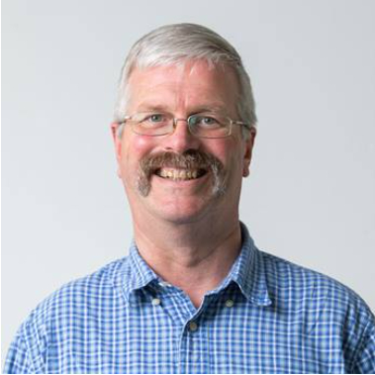 | Biography  Professor Chris Hunt is an Earth Scientist with broad interests in Quaternary science, archaeological science, palynology, sedimentology, molluscs, palaeoecology and palaeoenvironments.  Chris uses palynology to help in forensic cases. He also has interests in Late Jurassic and Early Cretaceous stratigraphy and palaeoenvironments and is a member of the international group working on the Jurassic-Cretaceous Boundary.  Chris has done research in many countries including the UK, Ireland, Malta, Libya, Italy, Spain, Switzerland, Jordan, Iraq, Vietnam, Borneo, Norway, and Canada.

Members wishing to visit the Central Teaching Hub for this lecture will be able to do so from 6.30 p.m.
Please note: For members and visitors reluctant to attend this live meeting, a Zoom transmission of the lecture will be arranged. To join the Zoom meeting for this lecture, please email the LGS Secretary via: lgssecretary@gmail.com
Members and visitors wishing to join this Zoom meeting will be able to do so from 7.15 p.m.
The lecture will start after the LGS Extraordinary Meeting that will start at 7.30 p.m.

Request for a lift to the Central Teaching Hub on March 8th
If you are a LGS member driving from the Formby or Crosby area and would be willing to pick up another LGS member to bring to this lecture, please contact the Secretary at: lgssecretary19@gmail.com

Down to Earth Magazine (DTE)
Hard copies of this publication are not being produced because of COVID-19 restrictions, but electronic copies are available, which we have permission to email to LGS members. If you would like a pdf copy of the most recent publication (DTE Extra number 110), please email Maggie Williams at: lgssecretary19@gmail.com

Cambridgeshire Geological Society

Monday 14th March 2022, 7.30pm
Virtual Lecture by Prof. Phil Gibbard and Dr. Marian Holness
Title: ‘Geological features of the Gog Magog Hills’
To register go to: http://www.cambsgeology.org/contact

Geologists Association (GA)
Four highlights from Geology from Your Sofa (GFYS)
The Geology of Arran 2021 Part 3: The Laggan Loop Part 2
https://www.youtube.com/watch?v=nNsvxAdeuxc

Early Tetrapod Feeding Mechanics
https://www.palaeocast.com/early-tetrapod-feeding-mechanics/

The geology of Mars
https://www.youtube.com/watch?v=JTh-HemASis

The age of giant swamps: Carboniferous
https://www.youtube.com/watch?v=7Ww6AFYBAQk

Geology Bites podcast series
The series consists of interviews with leading academic researchers, with a new episode being published every week or two: geologybites.com
Oliver Strimpel, Visiting Fellow in the Department of Earth Sciences, University of Oxford has forwarded this link. Members are welcome to visit the site. A wide range of topics have been covered, as summarized in the series index: geologybites.com/index . Each episode is supported by a dedicated web page.
Yorkshire Geological Society (YGS)
Thursday, 14th April 2022, 7.00 - 8.00p.m.
Webinar by Dr Nick Riley MBE, YGS President
Title: ‘Climate change, sea level rise and ocean acidification are now inevitable: is there a role for geoengineering?’
Register for this event via: https://www.yorksgeolsoc.org.uk/registrationnickriley

New Book - Publication date: 21 February 2022
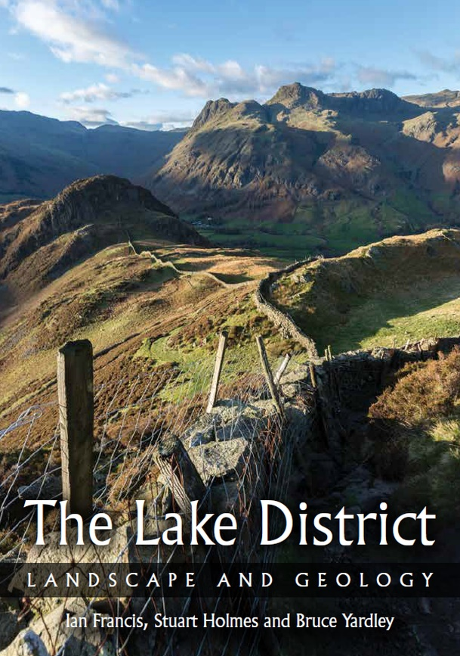 | This book introduces how the rocks of the Lake District formed and explains how the geology affects the landscape of this beautiful area. It also covers how the landscape has been shaped by natural processes such as glaciation and altered by human influences.  The book is very well-illustrated. The 230 illustrations include maps, diagrams, and colour photographs, which range from images of rock types and fossils to stunning aerial views and panoramas.  At the end of the book there are seven self-guided excursions. These feature easily accessible geological locations. A bonus is that there is a dedicated website, with a Google Earth photographic guide to all the main localities in the book:  https://www.lakedistrictgeology.co.uk/  Paperback: 235 x 165mm  Publisher: The Crowood Press  ISBN: 9780719840111  Price: £19.99

