14th May 2022

LGS Newsletter 163.11

Liverpool Geological Society events
Field excursion: Thurstaston Shore
Field Excursion Leader: Geoff Gilchrist
Date: Saturday 4th June 2022
Start time: 10.00 am.
Approximate finishing time: 12 noon.

Approximate walking distance: 1 km.

Terrain: An easy walk, mostly along the beach. There are easy access paths from the cliff top.

Meeting place: Meet at 10 am at Wirral Country Park Visitor Centre at end of Station Road, Thurstaston CH61 OHN. Lat/Long: 53°20′35.7′′N, 3°8′43.98′′W. There is plenty of on-site parking with an hourly charge (£1/hour). Wirral Country Park Visitor Centre will be open for toilet facilities.
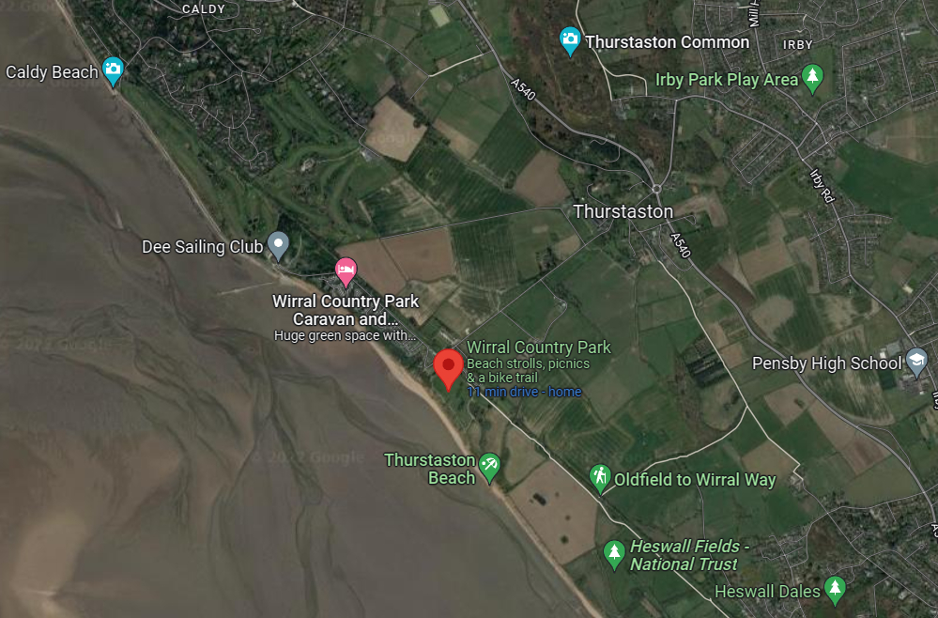
Nearest station (for those travelling by train): West Kirby, but no local public transport. If travelling by train, it is a 5.5 km walk along the Wirral Way from the station to the meeting place, but with notice it may be possible to arrange a pickup from West Kirby.
Clothing and equipment needed (e.g. safety helmets, waterproofs, food, rucksack etc): Strong footwear, high-vis jacket, waterproofs, and a safety helmet. Packed lunch suggested, although there are café facilities on site or close by.

Aim(s) of the visit: Consideration of the geological and geomorphological significance of the Dee estuary and adjacent land areas then a focus on the glacial till cliffs and beach.
If you wish to reserve a place on this excursion, please contact Geoff Gilchrist, Hon. Excursions Sec., by phone 0151 348 4437 mob: 07896 837 354 or email: gilchristge@gmail.com
Field excursion: Alexandra Slate Quarry
Field Excursion Leader: Alan Boyle
Date: Saturday 25th June 2022
Start time: 11:00 am
Approximate finish time: 16:00 pm
Approximate walking distance in km: 5km
Terrain: Follow footpaths up to and through a quarry. Elevation from ~260m up to ~420m Moel Tryfan) and back down on a grassy slope and then track:
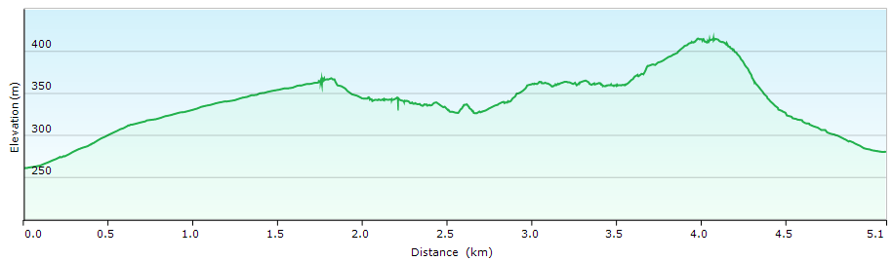
Graph of distance walked vs. topography from GPS track on 4 May 2022.
Meeting place (place name, post code, grid reference):  DPL Hygiene Supplies - Homewares Shop  Penyffridd  Caernarfon  LL54 7LB  Car parking (for those travelling by car): There is a hardstand just E of DPL.  GR: SH 50735 56740;  Lat/Long: N53° 05.216' W4° 13.814' | 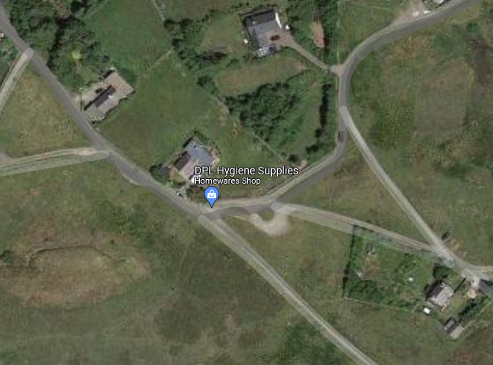

Nearest station (for those travelling by train): Caernarfon, but no local public transport.
Clothing & equipment needed (e.g. hard hats, waterproofs, food, rucksack etc): Hard hats essential and hi-vis jacket/waistcoat advised, plus normal outdoor gear for geological fieldwork. If you have an android or ipad tablet, that would be useful. Alan will prepare some things to download beforehand. We can also do some things with a smartphone if you don’t have a tablet.
The site is a SSSI, so no hammers.
Aim(s) of the day: To investigate Cambrian-age sediments and the effects of the Caledonian Orogeny. We will also visit Moel Tryfan, which has a geological connection to Charles Darwin. It was on a visit to Moel Tryfan on 26 August 1842 that Charles Darwin developed his ideas of marine submergence through the reported discovery of marine fossils by Joshua Trimmer (1795-1857), a geologist employed on the Geological Survey of England.
If you wish to reserve a place on this excursion, please contact Geoff Gilchrist, Hon. Excursions Sec., by phone 0151 348 4437 mob: 07896 837 354 or email: gilchristge@gmail.com

Field excursion: Formby (a date for your diary)
This will take place on Saturday 9th July 2022 and our field excursion leader will be Hazel Clark. Details to follow in the next LGS Newsletter

Birmingham’s erratic boulders
Thanks to National Lottery players, this project was developed in 2022 and seven walking and cycling trails in the Bromsgrove and SW Birmingham districts are available to showcase these fantastic boulders. Trail leaflets are available from: https://erraticsproject.org/erratic-boulder-trails/

Building Stones of Birmingham
Three leaflets which are guides to trails around the city centre and feature the building stones of Birmingham are now available. Download them as pdf files at: https://bcgs.info/pub/local-geology/building-stone-trails/

Devon County Council
Educational register of geological sites in Devon: a guide to geological fieldwork in Devon
This Register has been compiled by Devon County Council in partnership with English Nature and the Devon RIGS Group. By clicking on each of the geological sites in the index, you get maps, directions, explanations of the geology, diagrams, and photographs.
https://www.devon.gov.uk/geology/educational-register-of-geological-sites-in-devon/

Down to Earth Magazine (DTE)
Hard copies of this publication are not being produced because of COVID-19 restrictions, but electronic copies are available, which we have permission to email to LGS members. Please email Maggie Williams (Hon. Secretary): lgssecretary19@gmail.com if you would like pdf copies of these most recent publications:
DTE Issues - 118 February 2022 and 119 May 2022
DTE Extra - numbers 111, 112 & 113.

London Geodiversity Partnership
This site gives you links where you can download various geotrails in London:
http://londongeopartnership.org.uk/geotrails/

New book: Exploring Geoscience across the globe - England
The England version of Chris King’s original Exploring Geoscience online textbook was published on the IGEO website very recently. This new version of the book, written by Chris King, Elizabeth Devon, Peter Kennett, Pete Loader, and Maggie Williams, is free to download from:
http://www.igeoscied.org/teaching-resources/geoscience-text-books/

Shropshire: Locally Important Geological and Geomorphological Sites
Just a reminder that this site is worth browsing. It is a list of geological sites in Shropshire selected according to nationally agreed criteria: scientific value, educational interest, and historical importance.
http://www.shropshiregeology.org.uk/RIGS/RIGS_view.html
Please remember:
- The presence of a site on this list does not necessarily imply open or public access.
- Before visiting, you must investigate the situation at a particular site (including access by public rights of way and arrangements for car parking).

Yorkshire Geological Society (YGS) icehouse and back? A
Thursday, 30 June 2022, 7.00 – 8.00 p.m.
Webinar by Dr Jane Francis, British Geological Survey.W Professor Dame Jane
Title: Greenhouse to icehouse and back? Antarctica's future in a 400ppm world
From fossils of forests and dinosaurs to massive icesheets several km thick, this talk will cover the greenhouse to icehouse transition over the past 100 million years of Antarctica’s climate history. As our global climate warms, is Antarctica now on a reverse journey back to the greenhouse?
Register for this event via: https://www.yorksgeolsoc.org.uk/events-list/greenhouse-to-icehouse-and-back

