26th June 2022

LGS Newsletter 163.12

Sad news
It is with great sadness that we wish to report the passing of two long-standing members of the Society:
Winston (Mike) Fox and Michael Milne.
Mike Fox died in March 2022. Mike had been an active member of the Society and of the Wirral Lapidary Society. Sadly, in more recent years, Mike had been unable to attend most of the meetings of the Society.
Michael Milne, who died more recently, served as a member of LGS Council in session 163 and will be remembered as a very regular attendee at both indoor and outdoor meetings of the Society.

Liverpool Geological Society events
Field excursion: Formby
Field Excursion Leader: Hazel Clark
Date: Saturday 9th July 2022
Start time: 11.00 am.
Approximate finishing time: 2.00 pm.
Approximate walking distance: 1.5 km.
Terrain: A walk through the dunes on deep, dry sand to get to the beach.
Meeting place: Meet at 11.00am at the notice board at the southern end of Lifeboat Road car park [SD275065]. The address for Lifeboat Road car park is Lifeboat Road, Sefton, L37 2EB.
Lat/Long: 53°55′13.27” N, 3°9’57.44” W.
What three words: chosen toenail learns.
This car park is now a National Trust car park and there is a charge of £7.50 for non-members. Members need to bring their membership cards to avoid paying parking fees. https://www.nationaltrust.org.uk/formby
There are no toilet facilities at this meeting point.
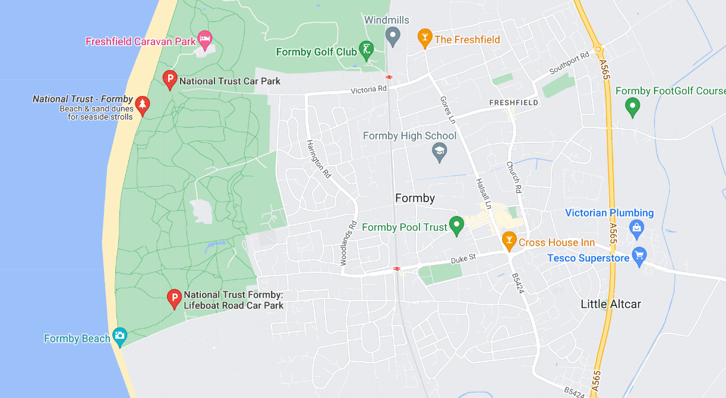
Nearest station (for those travelling by train): Formby station, which is about 1.5km from the car park.
Clothing and equipment needed (e.g. safety helmets, waterproofs, food, rucksack etc): Please wear suitable clothing and footwear for the weather conditions. If windy, there is a chance of blowing fine grained sand, so people wearing contact lenses may wish to bring glasses just in case. A packed lunch is suggested - there are no café facilities on site or close by. Please bring a hand lens/magnifying glass if you have one.

Aim(s) of the visit:
The aim is to look at the sediments and sedimentary structures in contrasting aeolian and beach environments.

If you wish to reserve a place on this excursion, please contact Geoff Gilchrist, Hon. Excursions Sec., by phone 0151 348 4437, mob: 07896 837 354, or email: gilchristge@gmail.com

Down to Earth Magazine (DTE)
Hard copies of this publication are not being produced because of COVID-19 restrictions, but electronic copies are available, which we have permission to email to LGS members. Please email Maggie Williams (Hon. Secretary): lgssecretary19@gmail.com if you would like pdf copies of the most recent publications:
DTE Extra - numbers 114 & 115.

